QINGHE FENGCHEN AUTO PARTS CO.LTD

E-mail：jane@qhfengchen.com
Skype：fengchenautoparts@qq.com
Wechat/wahtsAPP： +86 18931929497

（NO.) | Product name | Model | Picture | Describe | 产品毛重
FCXN-A01 | SHIFT KNOB | BMW 1 3 5 6 Series E30 E32 E34 E36 E38 E39 E46 E53 E60 E63 E83 E84 E90 E91 Etc.., BMW manual knob (MT) |  | Silver  5/6 Speed | 145.3
FCXN-A02 | SHIFT KNOB | BMW 1 3 5 6 Series E30 E32 E34 E36 E38 E39 E46 E53 E60 E63 E83 E84 E90 E91 Etc.., BMW manual knob (MT) | 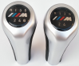 | Silver  5/6 Speed | 145.3
FCXN-A03 | SHIFT KNOB | BMW 1 3 5 6 Series E30 E32 E34 E36 E38 E39 E46 E53 E60 E63 E83 E84 E90 E91 Etc.., BMW manual knob (MT) | 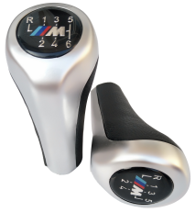 | Silver  5/6 Speed | 145.3
FCXN-A04 | SHIFT KNOB | BMW 1 3 5 6 Series E30 E32 E34 E36 E38 E39 E46 E53 E60 E63 E83 E84 E90 E91 Etc.., BMW manual knob (MT) |  | Silver  5/6 Speed | 145.3
FCXN-A05 | SHIFT KNOB | BMW 1 3 5 6 Series E30 E32 E34 E36 E38 E39 E46 E53 E60 E63 E83 E84 E90 E91 Etc.., BMW manual knob (MT) |  | Chrome  5/6 Speed | 145.3
FCXN-A06 | SHIFT KNOB | BMW 1 3 5 6 Series E30 E32 E34 E36 E38 E39 E46 E53 E60 E63 E83 E84 E90 E91 Etc.., BMW manual knob (MT) |  | Chrome  5/6 Speed | 145.3
FCXN-A07 | SHIFT KNOB | BMW 1 3 5 6 Series E30 E32 E34 E36 E38 E39 E46 E53 E60 E63 E83 E84 E90 E91 Etc.., BMW manual knob (MT) |  | Chrome  5/6 Speed | 145.3
FCXN-A08 | SHIFT KNOB | BMW 1 3 5 6 Series E30 E32 E34 E36 E38 E39 E46 E53 E60 E63 E83 E84 E90 E91 Etc.., BMW manual knob (MT) |  | Chrome  5/6 Speed | 145.3
FCXN-A09 | SHIFT KNOB | BMW 1 3 5 6 Series E30 E32 E34 E36 E38 E39 E46 E53 E60 E63 E83 E84 E90 E91 Etc.., BMW manual knob (MT) |  | Red  5/6 Speed | 145.3
FCXN-A10 | SHIFT KNOB | BMW 1 3 5 6 Series E30 E32 E34 E36 E38 E39 E46 E53 E60 E63 E83 E84 E90 E91 Etc.., BMW manual knob (MT) |  | Yellow  5/6 Speed | 145.3
FCXN-A11 | SHIFT KNOB | BMW 1 3 5 6 Series E30 E32 E34 E36 E38 E39 E46 E53 E60 E63 E83 E84 E90 E91 Etc.., BMW manual knob (MT) |  | Wood  5/6 Speed | 147.3
FCXN-A12 | SHIFT KNOB | BMW 1 3 5 6 Series E30 E32 E34 E36 E38 E39 E46 E53 E60 E63 E83 E84 E90 E91 Etc.., BMW manual knob (MT) |  | Wood  5/6 Speed | 147.3
FCXN-A13 | SHIFT KNOB | BMW 1 3 5 6 Series E30 E32 E34 E36 E38 E39 E46 E53 E60 E63 E83 E84 E90 E91 Etc.., BMW manual knob (MT) |  | Wood  5/6 Speed | 147.3
FCXN-A14 | SHIFT KNOB | BMW 1 3 5 6 Series E30 E32 E34 E36 E38 E39 E46 E53 E60 E63 E83 E84 E90 E91 Etc.., BMW manual knob (MT) | 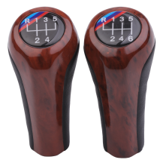 | Wood  5/6 Speed | 147.3
FCXN-A15 | SHIFT KNOB | BMW 1 3 5 6 Series E30 E32 E34 E36 E38 E39 E46 E53 E60 E63 E83 E84 E90 E91 Etc.., BMW manual knob (MT) |  | Black fibre  5/6 Speed | 147.3
FCXN-A16 | SHIFT KNOB | BMW 1 3 5 6 Series E30 E32 E34 E36 E38 E39 E46 E53 E60 E63 E83 E84 E90 E91 Etc.., BMW manual knob (MT) |  | Black fibre  5/6 Speed | 147.3
FCXN-A17 | SHIFT KNOB | BMW 1 3 5 6 Series E30 E32 E34 E36 E38 E39 E46 E53 E60 E63 E83 E84 E90 E91 Etc.., BMW manual knob (MT) |  | Black fibre  5/6 Speed | 147.3
FCXN-A18 | SHIFT KNOB | BMW 1 3 5 6 Series E30 E32 E34 E36 E38 E39 E46 E53 E60 E63 E83 E84 E90 E91 Etc.., BMW manual knob (MT) |  | Black fibre  5/6 Speed | 147.3
FCXN-A19 | SHIFT KNOB | BMW 1 3 5 6 Series E30 E32 E34 E36 E38 E39 E46 E53 E60 E63 E83 E84 E90 E91 Etc.., BMW manual knob (MT) |  | Gray fibre  5/6 Speed | 147.3
FCXN-A20 | SHIFT KNOB | BMW 1 3 5 6 Series E30 E32 E34 E36 E38 E39 E46 E53 E60 E63 E83 E84 E90 E91 Etc.., BMW manual knob (MT) |  | Gray fibre  5/6 Speed | 147.3
FCXN-A21 | SHIFT KNOB | BMW 1 3 5 6 Series E30 E32 E34 E36 E38 E39 E46 E53 E60 E63 E83 E84 E90 E91 Etc.., BMW manual knob (MT) |  | Gray fibre  5/6 Speed | 147.3
FCXN-A23 | SHIFT KNOB | BMW 1 3 5 6 Series E30 E32 E34 E36 E38 E39 E46 E53 E60 E63 E83 E84 E90 E91 Etc.., BMW manual knob (MT) |  | Gray fibre  5/6 Speed | 147.3
FCXN-A24 | SHIFT KNOB | BMW 1 3 5 6 Series E30 E32 E34 E36 E38 E39 E46 E53 E60 E63 E83 E84 E90 E91 Etc.., BMW manual knob (MT) | 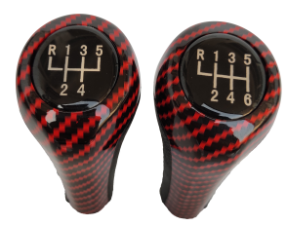 | Red fibre  5/6 Speed | 147.3
FCXN-A25 | SHIFT KNOB | BMW 1 3 5 6 Series E30 E32 E34 E36 E38 E39 E46 E53 E60 E63 E83 E84 E90 E91 Etc.., BMW manual knob (MT) |  | Red fibre  5/6 Speed | 147.3
FCXN-A26 | SHIFT KNOB | BMW 1 3 5 6 Series E30 E32 E34 E36 E38 E39 E46 E53 E60 E63 E83 E84 E90 E91 Etc.., BMW manual knob (MT) |  | Red fibre  5/6 Speed | 147.3
FCXN-A27 | SHIFT KNOB | BMW 1 3 5 6 Series E30 E32 E34 E36 E38 E39 E46 E53 E60 E63 E83 E84 E90 E91 Etc.., BMW manual knob (MT) |  | Red fibre  5/6 Speed | 147.3
FCXN-A28 | SHIFT KNOB | BMW 1 3 5 6 Series E30 E32 E34 E36 E38 E39 E46 E53 E60 E63 E83 E84 E90 E91 Etc.., BMW manual knob (MT) |  | Advanced Leather Superfibre Material with holes  5/6 Speed | 154.4
FCXN-A29 | SHIFT KNOB | BMW 1 3 5 6 Series E30 E32 E34 E36 E38 E39 E46 E53 E60 E63 E83 E84 E90 E91 Etc.., BMW manual knob (MT) |  | Advanced Leather Superfibre Material  5/6 Speed | 152
FCXN-A30 | SHIFT KNOB | BMW 1 3 5 6 Series E30 E32 E34 E36 E38 E39 E46 E53 E60 E63 E83 E84 E90 E91 Etc.., BMW manual knob (MT) |  | Advanced Leather Superfibre Material  5/6 Speed | 152
FCXN-A31 | SHIFT KNOB | BMW 1 3 5 6 Series E30 E32 E34 E36 E38 E39 E46 E53 E60 E63 E83 E84 E90 E91 Etc.., BMW manual knob (MT) |  | Advanced Leather Superfibre Material  5/6 Speed | 152
FCXN-A32 | SHIFT KNOB | BMW 1 3 5 6 Series E30 E32 E34 E36 E38 E39 E46 E53 E60 E63 E83 E84 E90 E91 Etc.., BMW manual knob (MT) |  | Advanced Leather Superfibre Material  5/6 Speed | 96.7
FCXN-A33 | SHIFT KNOB | BMW 1 3 5 6 Series E30 E32 E34 E36 E38 E39 E46 E53 E60 E63 E83 E84 E90 E91 Etc.., BMW manual knob (MT) |  | Advanced Leather Superfibre Material  5/6 Speed | 96.7
FCXN-A34 | SHIFT KNOB | BMW 1 3 5 6 Series E30 E32 E34 E36 E38 E39 E46 E53 E60 E63 E83 E84 E90 E91 Etc.., BMW manual |  | Advanced Leather Superfibre Material  5/6 Speed | 96.7
FCXN-A35 | SHIFT KNOB | BMW 1 3 5 6 Series E30 E32 E34 E36 E38 E39 E46 E53 E60 E63 E83 E84 E90 E91 Etc.., BMW manual knob (MT) | 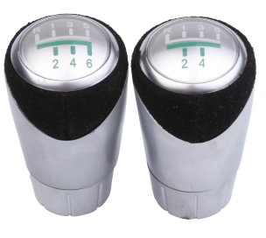 | 5/6 Speed
FCXN-A36 | SHIFT KNOB | BMW 1 3 5 6 Series E30 E32 E34 E36 E38 E39 E46 E53 E60 E63 E83 E84 E90 E91 Etc.., BMW manual knob (MT) |  | Advanced Leather Superfibre Material  5/6 Speed | 142.3
FCXN-A37 | SHIFT KNOB | BMW 1 3 5 6 Series E30 E32 E34 E36 E38 E39 E46 E53 E60 E63 E83 E84 E90 E91 Etc.., BMW manual knob (MT) | 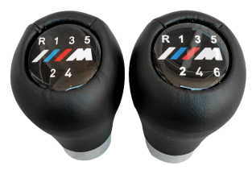 | Advanced Leather Superfibre Material  5/6 Speed | 142.3
FCXN-A38 | SHIFT KNOB | BMW 1 3 5 6 Series E30 E32 E34 E36 E38 E39 E46 E53 E60 E63 E83 E84 E90 E91 Etc.., BMW manual knob (MT) |  | Advanced Leather Superfibre Material  5/6 Speed | 142.3
FCXN-A39 | SHIFT KNOB | BMW 1 3 5 6 Series E30 E32 E34 E36 E38 E39 E46 E53 E60 E63 E83 E84 E90 E91 Etc.., BMW manual knob (MT) |  | Advanced Leather Superfibre Material  5/6 Speed | 142.3
FCXN-A40 | SHIFT KNOB | BMW 1 3 5 6 Series E30 E32 E34 E36 E38 E39 E46 E53 E60 E63 E83 E84 E90 E91 Etc.., BMW manual knob (MT) |  | PVC plastic black  5/6speed | 199.3
FCXN-A41 | SHIFT KNOB | BMW 1 3 5 6 Series E30 E32 E34 E36 E38 E39 E46 E53 E60 E63 E83 E84 E90 E91 Etc.., BMW manual knob (MT) |  | PVC plastic black  5/6speed | 199.3
FCXN-A42 | SHIFT KNOB | BMW 1 3 5 6 Series E30 E32 E34 E36 E38 E39 E46 E53 E60 E63 E83 E84 E90 E91 Etc.., BMW manual knob (MT) | 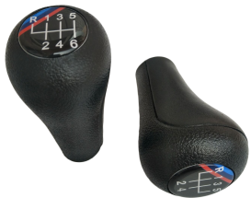 | PVC plastic black  5/6speed | 199.3
FCXN-A43 | SHIFT KNOB | BMW 1 3 5 6 Series E30 E32 E34 E36 E38 E39 E46 E53 E60 E63 E83 E84 E90 E91 Etc.., BMW manual knob (MT) | 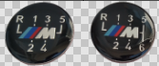 | PVC plastic black  5/6speed | 199.3
FCXN-A44 | SHIFT KNOB | BMW 1 3 5 6 Series E30 E32 E34 E36 E38 E39 E46 E53 E60 E63 E83 E84 E90 E91 Etc.., BMW manual knob (MT) | 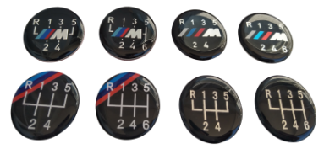 | BMW Label
FCXN-A45 | SHIFT KNOB | BMW 3 Series E36 E34 E30(1991-1998)/ E46(1999-2005) M3 | 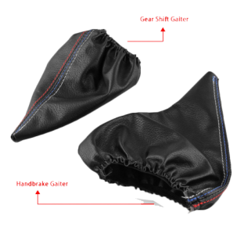 | PU leather
FCXN-A46 | SHIFT KNOB | For BMW 1 Series E87 116i 118i 120i 125i 128i 130i 135i 2004-2013  E87 E90 E92 X1  Etc.., BMW manual knob (MT) | 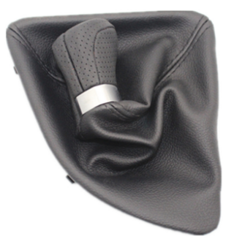 | PUleather+frame+knob  5/6 speed
FCXN-A47 | SHIFT KNOB | for BMW E36 E34 E28 E24 1998 1999 2000 2001 2002 2003 2004 2005 | 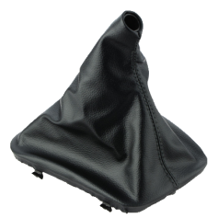 | PU leather
FCXN-B01 | SHIFT KNOB | For Mercedes Benz W202 C 93-01 W208 CLK 97-03 W210 E 95-03 | 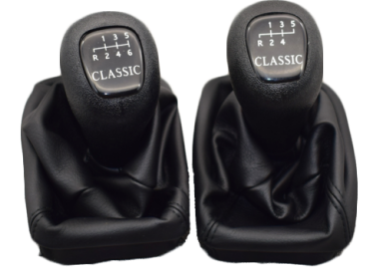 | CLASSIC  5/6speed | 199.2
FCXN-B02 | SHIFT KNOB | For Mercedes Benz W202 C 93-01 W208 CLK 97-03 W210 E 95-03 |  | CLASSIC  Only knob  5/6speed | 153.8
FCXN-B03 | SHIFT KNOB | For Mercedes Benz W202 C 93-01 W208 CLK 97-03 W210 E 95-03 |  | Only knob  5/6speed | 153.8
FCXN-B04 | SHIFT KNOB | For Mercedes Benz W202 C 93-01 W208 CLK 97-03 W210 E 95-03 |  | 5/6 speed | 199.2
FCXN-B05 | SHIFT KNOB | For Mercedes Benz W202 C 93-01 W208 CLK 97-03 W210 E 95-03 |  | AVANGARDE  5/6 speed | 153.8
FCXN-B06 | SHIFT KNOB | For Mercedes Benz W202 C 93-01 W208 CLK 97-03 W210 E 95-03 |  | ELEGANCE  5/6speed | 153.8
FCXN-B07 | SHIFT KNOB | For Mercedes-Benz C Class W203 | 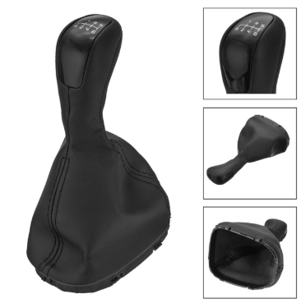 | 5/6 speed
FCXN-B08 | SHIFT KNOB | For Mercedes Benz C-Class W203 S203/W202 BJ (93-01)/A-Class W168(97-04) |  | 5/6 speed | 159.9
FCXN-B09 | SHIFT KNOB | For Mercedes Benz C-Class W203 S203/W202 BJ (93-01)/A-Class W168(97-04) |  | 5/6 speed | 159.9
FCXN-B10 | SHIFT KNOB | For Mercedes Benz C-Class W203 S203/W202 BJ (93-01)/A-Class W168(97-04) |  | 5/6 speed | 159.9
FCXN-B11 | SHIFT KNOB | For Mercedes Benz C-Class W203 S203/W202 BJ (93-01)/A-Class W168(97-04) |  | Leather + knob  5/6 speed | 177
FCXN-B12 | SHIFT KNOB | MercedeFor Mercedes Benz C-Class W203 S203/W202 BJ (93-01)/A-Class W168(97-04) |  | Leather + knob  5/6 speed | 177
FCXN-B13 | SHIFT KNOB | For Mercedes Benz C-Class W203 S203/W202 BJ (93-01)/A-Class W168(97-04) |  | Leather + knob  5/6speed | 177
FCXN-B14 | SHIFT KNOB | For Mercedes Benz C-Class W203 S203/W202 BJ (93-01)/A-Class W168(97-04) |  | 5/6 speed | 159.9
FCXN-B15 | SHIFT KNOB | For Mercedes Benz C-Class W203 S203/W202 BJ (93-01)/A-Class W168(97-04) |  | 5/6 speed | 159.9
FCXN-B16 | SHIFT KNOB | For Mercedes Benz C-Class W203 S203/W202 BJ (93-01)/A-Class W168(97-04) |  | 5/6 speed | 159.9
FCXN-B17 | SHIFT KNOB | For Mercedes Benz C-Class W203 S203/W202 BJ (93-01)/A-Class W168(97-04) |  | Leather + knob  5/6 speed | 177
FCXN-B18 | SHIFT KNOB | For Mercedes Benz C-Class W203 S203/W202 BJ (93-01)/A-Class W168(97-04) |  | Leather + knob  5/6 speed | 177
FCXN-B19 | SHIFT KNOB | For Mercedes Benz C-Class W203 S203/W202 BJ (93-01)/A-Class W168(97-04) |  | Leather + knob  5/6 speed | 177
FCXN-B20 | SHIFT KNOB | For Mercedes Benz VITO 638 w638 |  | 5speed | 169.7
FCXN-B21 | SHIFT KNOB | For Mercedes Benz VITO 638 w638 | 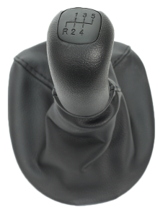 | Leather + knob  5speed | 194.1
FCXN-B22 | SHIFT KNOB | for Mercedes Benz W123 W140 W20 |  | 4/5 speed | 122.1
FCZJ-B23 | Car Bracket | for Mercedes Benz | 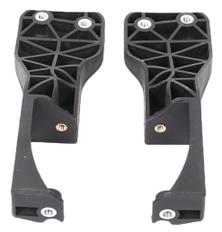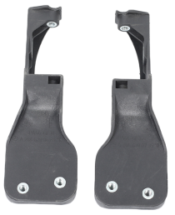 |  | 225.6
FCXN-C01 | SHIFT KNOB | AUDI A6 C5 (98-01) |  | Black/gray/beige | 147.5
FCXN-C02 | SHIFT KNOB | AUDI A6L |  | Black/gray/beige | 190.3
FCXN-C03 | SHIFT KNOB | For Audi A3 S3 2001 2002 2003 | 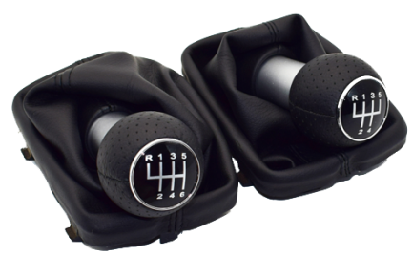 | Black Stitch  5/6speed | 121.7
FCXN-C04 | SHIFT KNOB | For Audi A3 S3 2001 2002 2003 | 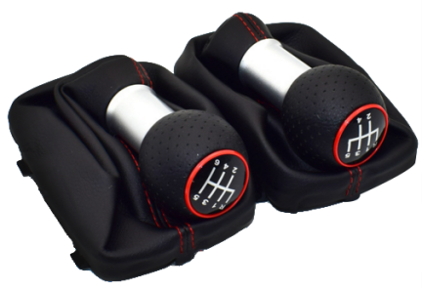 | Red Stitch  5/6speed | 121.7
FCXN-C05 | SHIFT KNOB | for Audi skoda seat A3 A4 B6 B7 b8 A6 S4 B8 8K A5 8T Q5 8R volkswagen vw passat golf 12mm | 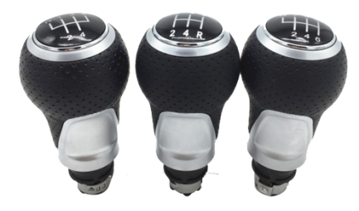 | Chrome  5/6speed
FCXN-C06 | SHIFT KNOB | for Audi skoda seat A3 A4 B6 B7 b8 A6 S4 B8 8K A5 8T Q5 8R volkswagen vw passat golf 12mm | 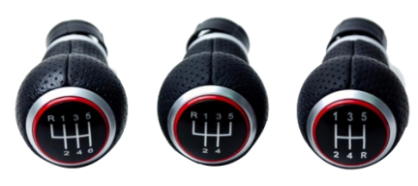 | Red  5/6speed
FCXN-C07 | SHIFT KNOB | For Audi A3 S3 2001 2002 2003  volkswagen vw passat golf 12mm | 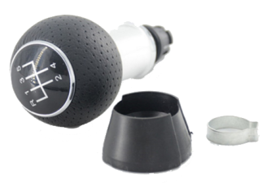 | Chrome  5/6speed | 91.3
FCXN-C08 | SHIFT KNOB | For Audi A3 S3 2001 2002 2003  volkswagen vw passat golf 12mm | 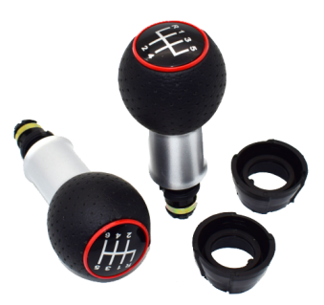 | Red  5/6speed | 91.3
FCXN-C09 | SHIFT KNOB | for Audi A5 A4L Q5 B8 B8PA B9 2009 2010 2011 2012 2013 2014 2015 2016 | 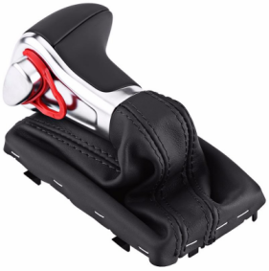 | (AT)  Automatic knob
FCXN-C10 | SHIFT KNOB | For Audi Q3 A4 A5 A6 A7 A1 A3 Q5 VW Golf CC DSG | 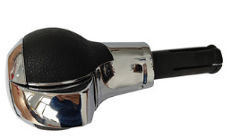 | (AT)  Automatic knob
FCXN-C11 |  | For Audi A4 S4 B8 8K A5 8T Q5 8R S Line 07-15 | 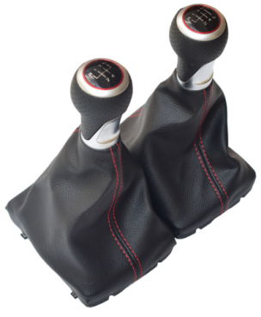 | Red Stitch  5/6speed
FCXN-D01 | SHIFT KNOB | VOLKSWAGEN (GOLF4,BORA 98-04) |  | Red  5/6speed  12/23mm | 188.3
FCXN-D02 | SHIFT KNOB | VOLKSWAGEN (GOLF4,BORA 98-04) |  | Blue  5/6speed  12/23mm | 188.3
FCXN-D03 | SHIFT KNOB | VOLKSWAGEN (GOLF4,BORA 98-04) |  | Black  5/6speed  12/23mm | 188.3
FCXN-D04 | SHIFT KNOB | VOLKSWAGEN (GOLF4,BORA 98-04) |  | Chrome  5/6speed  12/23mm | 188.3
FCXN-D05 | SHIFT KNOB | VOLKSWAGEN (GOLF4,BORA 98-04) |  | Silver cap  5/6speed  12/23mm | 188.3
FCXN-D06 | SHIFT KNOB | VOLKSWAGEN (GOLF4,BORA 98-04) |  | Blue leather  5/6speed  12/23mm | 188.3
FCXN-D07 | SHIFT KNOB | VOLKSWAGEN (GOLF4,BORA 98-04) |  | Red Leather  5/6speed  12/23mm | 188.3
FCXN-D08 | SHIFT KNOB | VOLKSWAGEN (GOLF4,BORA 98-04) |  | Wood  5/6speed  12/23mm | 181.2
FCXN-D09 | SHIFT KNOB | VOLKSWAGEN (GOLF4,BORA 98-04) |  | Wood silver cap  5/6speed  12/23mm | 181.2
FCXN-D10 | SHIFT KNOB | VW GOLF4 (Audi A3 knob+GOLF4 leather boot) Beige | 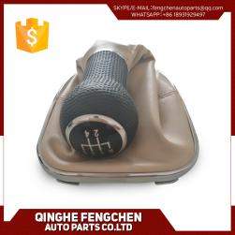 | Beige leather  5/6speed  12/23mm | 188.3
FCXN-D11 | SHIFT KNOB | VW GOLF4 (Audi A3 knob+GOLF4 leather boot) chrome | 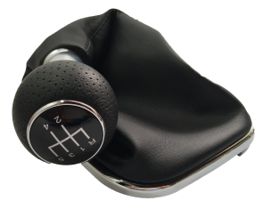 | Chrome  5/6speed | 144.3
FCXN-D12 | SHIFT KNOB | VW GOLF4 (Audi A3 knob+GOLF4 leather boot) Red |  | Red  5/6speed | 144.3
FCXN-D13 | SHIFT KNOB | VOLKSWAGEN GOLF4 | 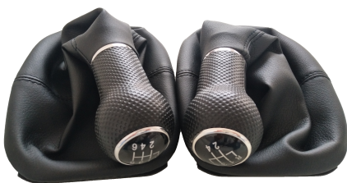 | Black  5/6speed  12/23mm | 181.7
FCXN-D14 | SHIFT KNOB | VOLKSWAGEN GOLF4 | 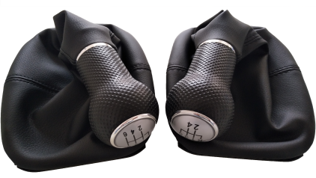 | Silver  5/6speed  12/23mm | 181.7
FCXN-D15 | SHIFT KNOB | VOLKSWAGEN GOLF4 |  | Blue  5/6speed  12/23mm | 181.7
FCXN-D16 | SHIFT KNOB | VOLKSWAGEN GOLF4 |  | Red  5/6speed  12/23mm | 181.7
FCXN-D17 | SHIFT KNOB | VW for Polo Golf MK4 Seat IBIZA |  | Chrome  5/6speed  12/23mm | 161.9
FCXN-D18 | SHIFT KNOB | VW for Polo Golf MK4 Seat IBIZA |  | Red stitch  5/6speed  12/23mm | 161.9
FCXN-D19 | SHIFT KNOB | VW for Polo Golf MK4 Seat IBIZA |  | Red cap  5/6speed  12/23mm | 161.9
FCXN-D20 | SHIFT KNOB | VW for Polo Golf MK4 Seat IBIZA |  | A3 knob  5/6speed
FCXN-D21 | SHIFT KNOB | For VW Golf 6 A6 MK6 For GTI GTD R20 09-13 | 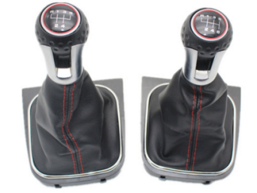 | Red  5/6speed
FCXN-D22 | SHIFT KNOB | VOLKSWAGEN PASSAT B5 (96-05) | 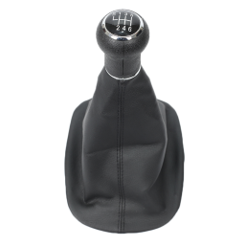 | Black  5/6speed | 150.2
FCXN-D23 | SHIFT KNOB | VOLKSWAGEN PASSAT B5 (96-05) | 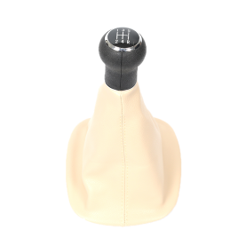 | Beige  5/6speed | 150.2
FCXN-D24 | SHIFT KNOB | VOLKSWAGEN PASSAT B5 (96-05) | 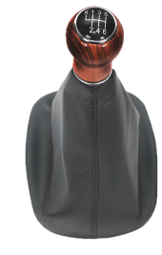 | Wood knob  5/6speed | 143.3
FCXN-D25 | SHIFT KNOB | VOLKSWAGEN PASSAT B5 (96-05) | 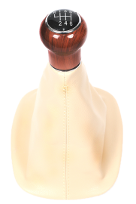 | Wood knob  5/6speed | 143.3
FCXN-D26 | SHIFT KNOB | VW Passat B5plus 3BG(01-05) | 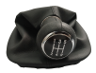 | Black
FCXN-D27 | SHIFT KNOB | VW Passat B6  3C(05-10)  5/6 Speed, | 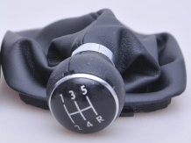 | black
FCXN-D28 | SHIFT KNOB | VW Mk4 Golf Jetta (1999-2005) |  | black | 168.2
FCXN-D29 | SHIFT KNOB | VW POLO ( 2002-2009) | 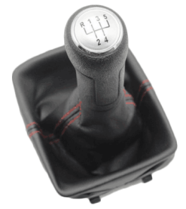 | Silver cap
FCXN-D30 | SHIFT KNOB | VW POLO ( 2002-2009) | 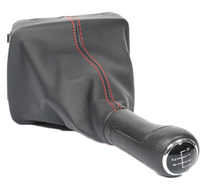 | Red stitch
FCXN-D31 | SHIFT KNOB | VW POLO ( 2002-2009) |  | Black
FCXN-D32 | SHIFT KNOB | VW Volkswagen Gol |  | Chrome  5/6speed | 167.1
FCXN-D33 | SHIFT KNOB | VW Volkswagen Gol | 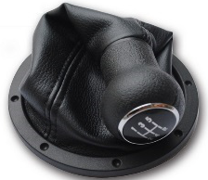 | Black  5/6speed | 167.1
FCXN-D34 | SHIFT KNOB | For VW Golf 6 MK5 MK6 Jetta 2005 2006 2007-2014 |  | Black  5/6speed | 191.2
FCXN-D35 | SHIFT KNOB | For VW Golf 6 MK5 MK6 Jetta 2005 2006 2007-2014 |  | Silver cap  Black stitch  5/6speed | 191.2
FCXN-D36 | SHIFT KNOB | For VW Golf 6 MK5 MK6 Jetta 2005 2006 2007-2014 |  | Silver cap  Red stitch  5/6speed | 191.2
FCXN-D37 | SHIFT KNOB | For VW Golf 6 MK5 MK6 Jetta 2005 2006 2007-2014 | 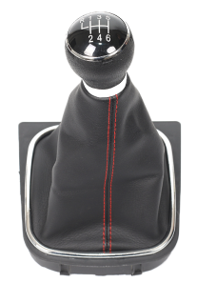 | Red stitch  5/6speed | 191.2
FCXN-D38 | SHIFT KNOB | VW Touran Caddy (2003-2011) | 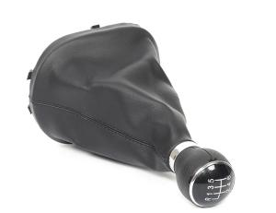 | Black leather  5/6speed | 156.2
FCXN-D39 | SHIFT KNOB | VW Touran Caddy (2003-2011 | 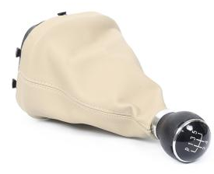 | Beige leather  5/6speed | 156.2
FCXN-D40 | SHIFT KNOB | For VW Jetta 5 6 GOLF 6 VI MK5 MK6 5KD 711 113 5KD711113 | 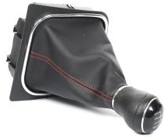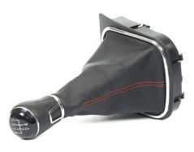 | Red stitch  5/6speed
FCXN-D41 | SHIFT KNOB | For VW Jetta 5 6 GOLF 6 VI MK5 MK6 5KD 711 113 5KD711113 | 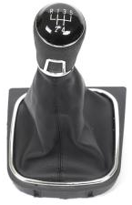 | 5/6speed
FCXN-D42 | SHIFT KNOB | For VW Jetta 5 6 GOLF 6 VI MK5 MK6 5KD 711 113 5KD711113 | 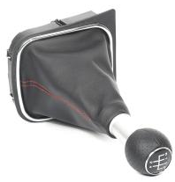 | 5/6speed  Refit A3 knob  Red stitch
FCXN-D43 | SHIFT KNOB | VW Jetta 13-15 | 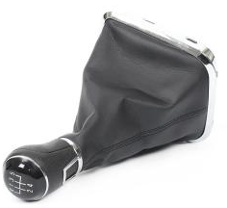 | 5/6speed  Chrome | 203.2
FCXN-D44 | SHIFT KNOB | VW Jetta 13-15 | 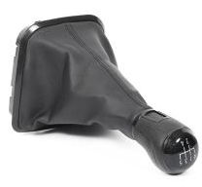 | 5/6speed  Black | 203.2
FCXN-D45 | SHIFT KNOB | for VW PASSAT B6 B7 CC 2005-2013 |  | 5/6speed | 182.5
FCXN-D46 | SHIFT KNOB | for VW PASSAT B6 B7 CC 2005-2013 |  | 5/6speed | 145.9
FCXN-D47 | SHIFT KNOB | For VW Golf 7 A7 MK7 For GTI GTD | 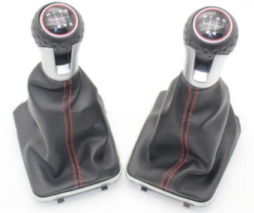 | Red stitch  5/6speed
FCXN-D48 | SHIFT KNOB | VW TransporterT5 T6 MKV MKVI(03-11) | 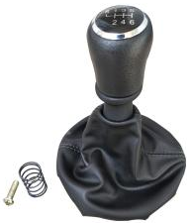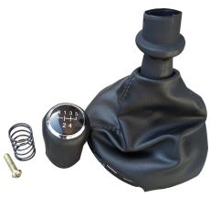 | Black  5/6speed | 152.8
FCXN-D49 | SHIFT KNOB | VW TransporterT5 T6 MKV MKVI(03-11) | 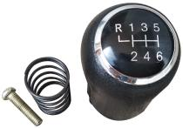 | 5/6speed | 94.2
FCXN-D50 | SHIFT KNOB | VW TransporterT5 T6 MKV MKVI(03-11) |  | Silver cap  Black stirch  5/6speed | 152.8
FCXN-D51 | SHIFT KNOB | VW TransporterT5 T6 MKV MKVI(03-11) |  | Silver cap  Red stirch  5/6speed | 152.8
FCXN-D52 | SHIFT KNOB | VW(05-10) Jetta Vento Bora MK5 |  | chrome | 174.7
FCXN-D53 | SHIFT KNOB | VW GOLF4,BORA |  | Wood  5/6speed
FCXN-D54 | SHIFT KNOB | VW Passat b5 |  | Wood  5/6speed
FCXN-D55 | SHIFT KNOB | VW Golf IV Red 12/23MM | 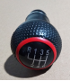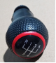 | Red  5/6speed
FCXN-D56 | SHIFT KNOB | VW Golf IV Blue 12/23MM | 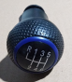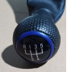 | Blue  5/6speed
FCXN-D57 | SHIFT KNOB | VW Golf IV Black 12/23MM | 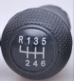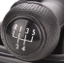 | Black  5/6speed
FCXN-D58 | SHIFT KNOB | VW Golf IV chrome 12/23MM | 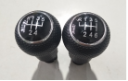 | Chrome  5/6speed
FCXN-D59 | SHIFT KNOB | VW Golf IV silver cap 12/23MM | 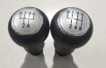 | Silver  5/6speed
FCXN-D60 | SHIFT KNOB | VW GOLF6 | 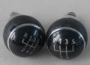 | Chrome  5/6speed
FCXN-D61 | SHIFT KNOB | VW POLO silver | 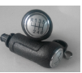 | Silver cap  5/6speed
FCXN-D62 | SHIFT KNOB | VW POLO | 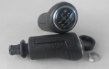 | Black cap  5/6speed
FCXN-D63 | SHIFT KNOB | VOLKSWAGEN  Golf | 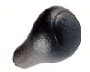 | Black 5speed
FCXN-D64 | SHIFT KNOB | VW PASSAT B7 / GOLF6 |  | Black  5/6speed
FCXN-D65 | SHIFT KNOB | VW PASSAT B7 / GOLF6 |  | Chrome  5/6speed
FCXN-E01 | SHIFT KNOB | Skoda Octivia II 04-11 |  | Chrome  5/6speed | 216.2
FCXN-E02 | SHIFT KNOB | Skoda Octivia II 04-11 | 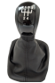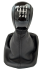 | Black  5/6speed | 216.2
FCXN-E03 | SHIFT KNOB | Skoda Octivia II 04-11 | 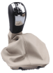 | Beige leather  5/6speed | 216.2
FCXN-E04 | SHIFT KNOB | Skoda Fabia(00-08) | 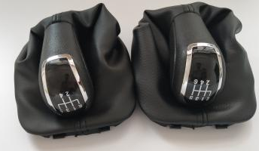 | Black 5/6speed
FCXN-E05 | SHIFT KNOB | Skoda Fabia(00-08) | 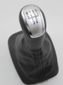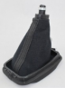 | Silver cap  5/6speed
FCXN-E06 | SHIFT KNOB | Skoda Superb 3T MKII (08-12) | 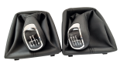 | 5/6speed | 196.6
FCXN-E07 | SHIFT KNOB | Skoda Superb 3T MKII (08-12) silver | 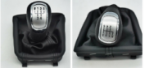 | Silver  5/6speed | 196.6
FCXN-E08 | SHIFT KNOB | Skoda Fabia II (06-10) Silver | 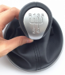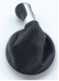 | Silver  5/6speed | 174.3
FCXN-E09 | SHIFT KNOB | Skoda Fabia II (06-10) Black | 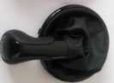 | Black  5/6speed | 174.3
FCXN-E10 | SHIFT KNOB | Skoda Octivia (1997-2011) | 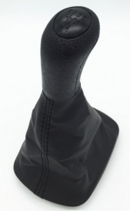 | Black  5speed | 232.7
FCXN-E11 | SHIFT KNOB | Skoda A7 A5 |  | Chrome  5/6speed
FCXN-F01 | SHIFT KNOB | Peugeot 206 207 307 308 408 508 2008 301  Citroen C2 C3 C4L C5 Picasso Elysee C-Triomphe |  | Chrome  Automatic knob | 95.9
FCXN-F02 | SHIFT KNOB | Peugeot 106 107 205 206 306 406 307 308 3008 Citroen Picasso Saxo C1 C2 C4 | 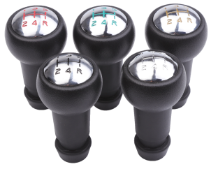 | Red, green, gold,  chrome | 181.4
FCXN-F03 | SHIFT KNOB | Peugeot 106 107 205 206 306 406 307 308 3008 Citroen Picasso Saxo C1 C2 C4 |  | black | 181.4
FCXN-F04 | SHIFT KNOB | CITROEN C1 C3 C4 / For PEUGEOT 106 107 205 206 207 306 307 308 309 405 406 407 508 605 607 806 807 |  | Silver cap | 100.4
FCXN-F05 | SHIFT KNOB | CITROEN C1 C3 C4 / For PEUGEOT 106 107 205 206 207 306 307 308 309 405 406 407 508 605 607 806 807 | 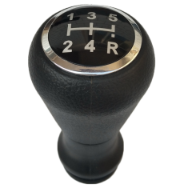 | Black cap | 100.4
FCXN-F06 | SHIFT KNOB | CITROEN C1 C3 C4 / For PEUGEOT 106 107 205 206 207 306 307 308 309 405 406 407 508 605 607 806 807 |  | Chrome cap | 99.5
FCXN-F07 | SHIFT KNOB | CITROEN C1 C3 C4 / For PEUGEOT 106 107 205 206 207 306 307 308 309 405 406 407 508 605 607 806 807 |  | Chrome black | 99.5
FCXN-F08 | SHIFT KNOB | PEUGEOT /CITROEN | 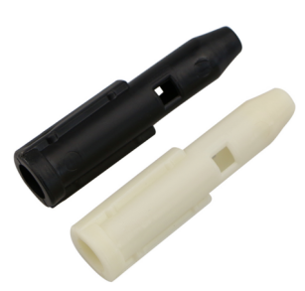 | Adapter sleeve  Black, white | 4.2
FCXN-F09 | SHIFT KNOB | Peugeot 207 307 CC 308 |  | Chrome | 235.8
FCXN-F10 | SHIFT KNOB | For PEUGEOT 307 308 3008 407 5008 807 PARTNER B9 TEPEE Gear Shift Knob 6 speed for citron C3 (A51) C4, C4 Picasso |  | Leather+chrome
FCXN-F11 | SHIFT KNOB | For Peugeot 106 206 207 307 308 406 408 | 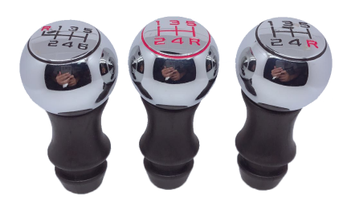 | Aluminium alloy  Sports | 168
FCXN-F12 | SHIFT KNOB | For Peugeot 106 206 207 307 308 406 408 |  | Aluminium alloy | 168
FCXN-F13 | SHIFT KNOB | Peugeot 307 for Citroen C4 Triumph Sega | 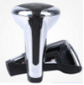 | Chrome
FCXN-F14 | SHIFT KNOB | Peugeot 206 207 307 308 408 508 2008 301 Citroen C2 C3 C4L C5 Picasso Elysee | 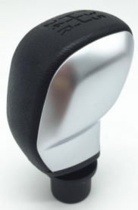 | black
FCXN-F15 | SHIFT KNOB | Peugeot 307 308 407 408 106 206 206CC Sega Elysee C2 | 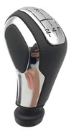 | black
FCXN-F16 | SHIFT KNOB | Peugeot 307 308  Citroen C2 C3 |  | black
FCXN-F17 | SHIFT KNOB | Citroen C2 for Peugeot 206 207 307 408 |  | chrome | 139.6
FCXN-G01 | SHIFT KNOB | For Ford Focus Mondeo MK3 S-MAX C-MAX Mustang Galaxy Fiesta MK6 Transit universal |  | Silver 5/6 speed | 130.6
FCXN-G02 | SHIFT KNOB | For Ford Focus Mondeo MK3 S-MAX C-MAX Mustang Galaxy Fiesta MK6 Transit universal |  | Black 5/6speed | 130.6
FCXN-G03 | SHIFT KNOB | For Ford Focus Mondeo MK3 S-MAX C-MAX Mustang Galaxy Fiesta MK6 |  | Silver 5/6speed | 184.8
FCXN-G04 | SHIFT KNOB | For Ford Focus Mondeo MK3 S-MAX C-MAX Mustang Galaxy Fiesta MK6 |  | Black 5/6speed | 184.8
FCXN-G05 | SHIFT KNOB | FORD FOCUS MK2 (2004-2012)/silver |  | Black 5/6speed | 113.2
FCXN-G06 | SHIFT KNOB | FORD FOCUS MK2 (2004-2012)/Black |  | Silver 5/6speed | 113.2
FCXN-G07 | SHIFT KNOB | Ford focus 04-12 |  | Red leather
FCXN-G08 | SHIFT KNOB | Ford focus 04-12 |  | Black leather
FCXN-G09 | SHIFT KNOB | Ford focus 04-12 |  | Black leather
FCXN-G10 | SHIFT KNOB | Ford Focus 2 MK2 2005 - 2011 Fiesta Kuga 08-12 | 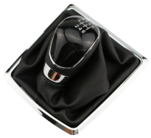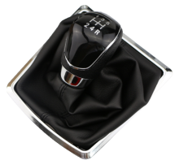 | Black 5/6speed | 172.7
FCXN-G11 | SHIFT KNOB | Ford Focus 2 MK2 2005 - 2011 Fiesta Kuga 08-12 | 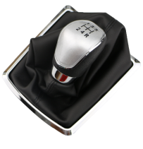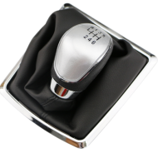 | Silver 5/6speed | 172.7
FCXN-G12 | SHIFT KNOB | For Ford Mondeo Focus | 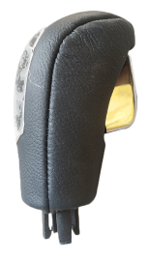 | (AT)  Automatic knob
FCXN-G13 | SHIFT KNOB | Ford focus 04-12 |  | Black 5/6speed
FCXN-H01 | SHIFT KNOB | For Toyota Corolla 1.8MT AVENSIS YARIS D4D URBAN RAV4 CRUISER SCION |  | Silver  5/6speed | 67.6
FCXN-H02 | SHIFT KNOB | For Toyota Corolla 1.8MT AVENSIS YARIS D4D URBAN RAV4 CRUISER SCION |  | Black  5/6 speed | 67.6
FCXN-H03 | SHIFT KNOB | for Toyota AYGO 2005-2014 for Toyota Verso 2002-2009  for Toyota Corolla 1992-2009  for Toyota RAV4 1994-2000  for Toyota AVENSIS 1997-2008  for Toyota YARIS/VITZ 1999-2005 |  | Chrome  5/6speed | 116
FCXN-H04 | SHIFT KNOB | Toyota Camry Rav4 | . | (AT) wood  Automatic knob | 96.2
FCXN-H05 | SHIFT KNOB | Toyota Camry Rav4 | 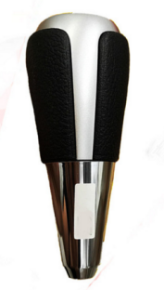 | (AT) chrome  Automatic knob
FCXN-H06 | SHIFT KNOB | for Toyota AYGO Verso  Corolla  RAV4  AVENSIS YARIS/VITZ |  | Black  5/6speed | 116
FCXN-H07 | SHIFT KNOB | Toyota Corolla (07-1 3) (16*10.2*17cm) | 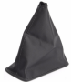 | Black/gray
FCXN-H08 | SHIFT KNOB | Honda civic | 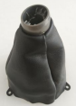 | Leather cover  black
FCXN-H09 | SHIFT KNOB | HONDA | 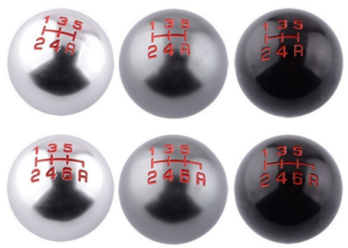 | aluminum  5/6speed
FCXN-H10 | SHIFT KNOB | HONDA | 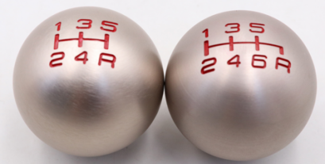 | Aluminum  5/6speed
FCXN-J01 | SHIFT KNOB | RENAULT CLIO MK3 3 III MEGANE MK2 SCENIC MK2 |  | Black5/6speed | 124.2
FCXN-J02 | SHIFT KNOB | RENAULT CLIO MK3 3 III MEGANE MK2 SCENIC MK2 |  | Black  5/6speed | 124.2
FCXN-J03 | SHIFT KNOB | RENAULT CLIO - 2 PHASE,KANGOO |  | Silver | 87.6
FCXN-J04 | SHIFT KNOB | RENAULT CLIO - 2 PHASE,KANGOO |  | black | 109.1
FCXN-J05 | SHIFT KNOB | RENAULT CLIO - 2 PHASE,KANGOO |  | Leather knob | 137.1
FCXN-J06 | SHIFT KNOB | For Renault Megane Scenic Clio Kangoo Vauxhall Opel Nissan |  | Leather knob
FCXN-J07 | SHIFT KNOB | OPEL CORSA C 2000-2005 COMBO C 2001-2011 MERIVA A |  | black | 90.9
FCXN-J08 | SHIFT KNOB | Opel/Vauxhall/Insignia Automatic | 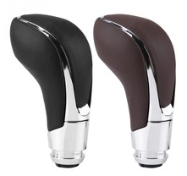 | Black/brown  Automatic knob | 95.9
FCXN-J09 | SHIFT KNOB | Opel Astra 5 Vauxhall 2004 2005 2006 2007 2008 Vectra A Calibra Kadett E Corsa B |  | Leather cover | 67
FCXN-J10 | SHIFT KNOB | OPEL | 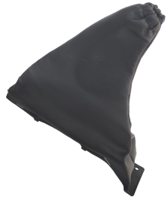 | Leather cover
FCXN-J11 | SHIFT KNOB | OPEL  ASTRA II G (98-10)  ZAFIRA A (99-06) |  | Leather cover | 57.1
FCXN-J12 | SHIFT KNOB | For Opel Astra Vectra Calibra Kadett Corsa |  | Leather cover | 57.8
FCXN-J13 | SHIFT KNOB | Astra H III iii MK5 Zafira B Corsa |  | Black  5/6speed
FCXN-J14 | SHIFT KNOB | OPEL |  | black | 82.2
FCXN-K01 | SHIFT KNOB | For Suzuki Swift 2005-2010 SX4 | 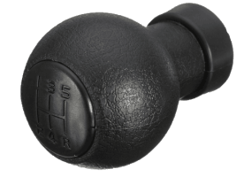 | black | 167.8
FCXN-K02 | SHIFT KNOB | For Suzuki Swift 2005-2010 SX4 |  | chrome | 167.8
FCXN-K03 | SHIFT KNOB | For Suzuki Swift MK2 05-10 |  | black
FCXN-K04 | SHIFT KNOB | For Suzuki Swift MK2 05-10 | 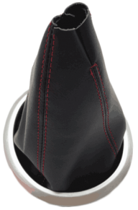 | Silver  Red stitch
FCXN-K05 | SHIFT KNOB | Mitsubishi Motors | 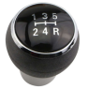 | black | 78.7
FCXN-K06 | SHIFT KNOB | For Mazda 3 5 6 323 626 RX-8 Premavy Mpv |  | Chrome  5/6speed | 197.4
FCXN-K07 | SHIFT KNOB | Mazda Protege 323 98-03 | 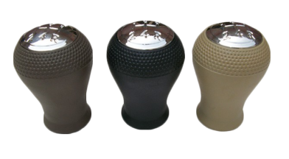 | Gray,black,beige
FCXN-L01 | SHIFT KNOB | Chevrolet Chevy Cruze 08 - 12 |  | 5/6speed | 122.6
FCXN-L02 | SHIFT KNOB | Chevrolet Chevy Cruz |  | Red stitch
FCXN-L03 | SHIFT KNOB | Chevrolet Chevy Cruz |  | Black stitch
FCXN-L04 | SHIFT KNOB | Chevrolet sail |  | black
FCXN-M01 | SHIFT KNOB | OPEL | 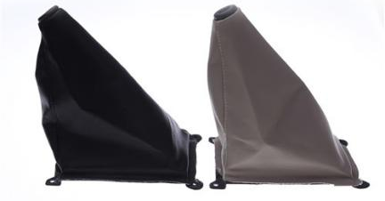 | Beige/black
FCXN-M02 | SHIFT KNOB | KIA Sportage |  | black
FCXN-M03 | SHIFT KNOB | KIA Elantra |  | black
FCXN-M04 | SHIFT KNOB | For 2000 2002 2003 Hyundai Elantra Avante XD | 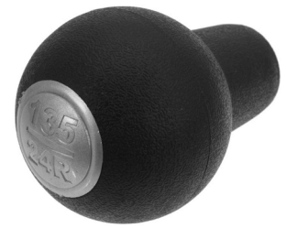 | black | 113.8
FCXN-M05 | SHIFT KNOB | Kia Forte |  | black
FCXN-M06 | SHIFT KNOB | KIA Tucson |  | black
FCXN-M07 | SHIFT KNOB | KIA Cerato |  | black
FCXN-M08 | SHIFT KNOB | for Hyundai Elantra GT Accent Solaris Avante MD I30 MT | 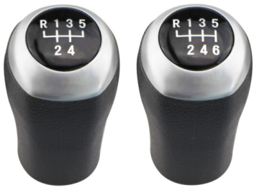 | Gray/black | 145.5
FCXN-M09 | SHIFT KNOB | For Hyundai Getz  02-10 | 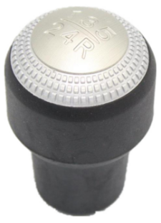 | black
FCXN-M10 | SHIFT KNOB | for Kia Forte Soul FOR Hyundai Elantra I30 | 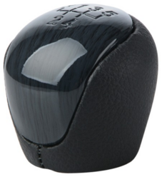 | black
FCXN-M11 | SHIFT KNOB | for Kia Forte Soul FOR Hyundai Elantra I30 | 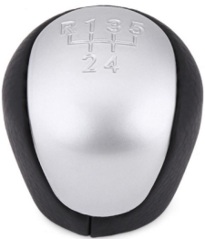 | silver
FCXN-M12 | SHIFT KNOB | For Hyundai Sonata 8 | 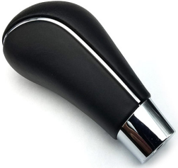 | Automatic knob  black
FCXN-N01 | SHIFT KNOB | 1994-2006 FIAT DUCATO / CITROEN JUMPER RELAY | 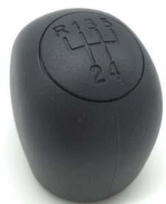 | black
FCXN-N02 | SHIFT KNOB | FOR Fiat Ducato For Citroen Jumper Relay for Peugeot Boxer 2002-2014 | 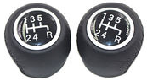 | Black  5speed
FCXN-N03 | SHIFT KNOB | FOR Fiat Ducato For Citroen Jumper Relay for Peugeot Boxer 2002-2014 | 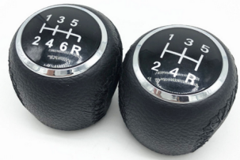 | Black  5/6speed
FCXN-N04 | SHIFT KNOB | Fiat 500 | 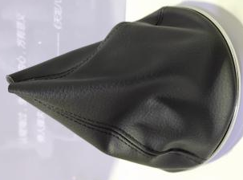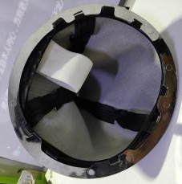 | Black  Leather cover
FCBT-Z01 | Steering wheel cover | PU leather |  | black | 120.1
FCBT-Z02 | Steering wheel cover | PU leather | 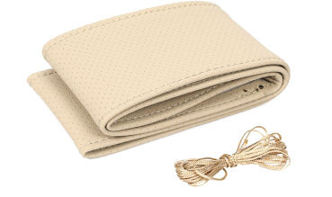 | beige | 76.1
FCBT-Z03 | Steering wheel cover | Pu leather | 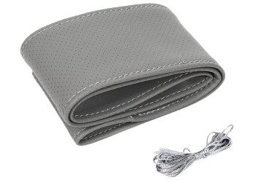 | gray | 109
FCBT-Z04 | Steering wheel cover | Real leather | 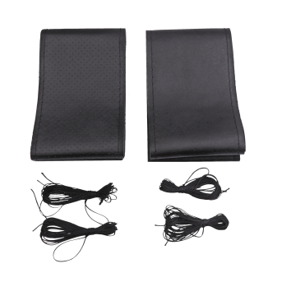 | Black
FCBT-Z05 | Steering wheel cover | Real leather | 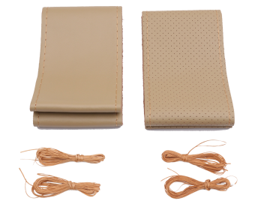 | beige
FCBT-Z06 | Steering wheel cover | Real leather | 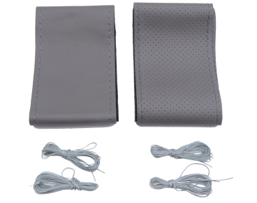 | gray
FCTX-S01 | Decorative antenna | Plastic |  | black
FCTX-S02 | Decorative antenna | Plastic |  | black
FCTX-S03 | Decorative antenna | Plastic |  | fibre

