Dear Sir/madam：
I am from liaocheng teriheng mechanical accessories co., LTD., a company in China. We mainly produce auto jacks and jack accessories. There are four types of hand jacks, namely 0.8 ton, 1 ton, 1.5 ton and 2 ton.All year round foreign processing of metal stamping pieces, but also can provide agents of all kinds of commodities and technology import and export business.Below is our company's existing product details, looking forward to your reply!
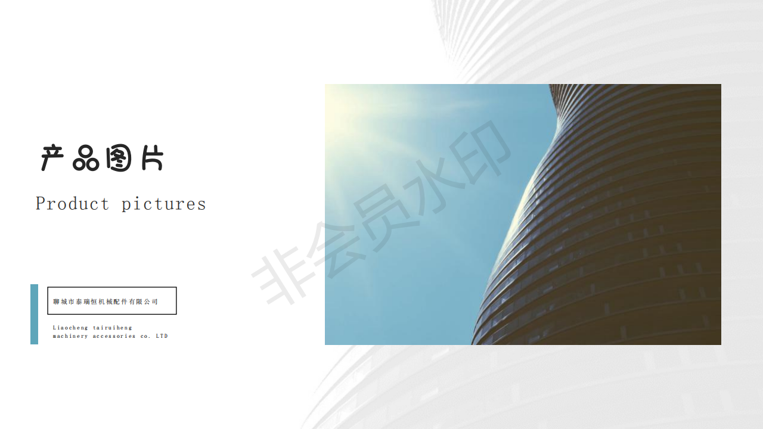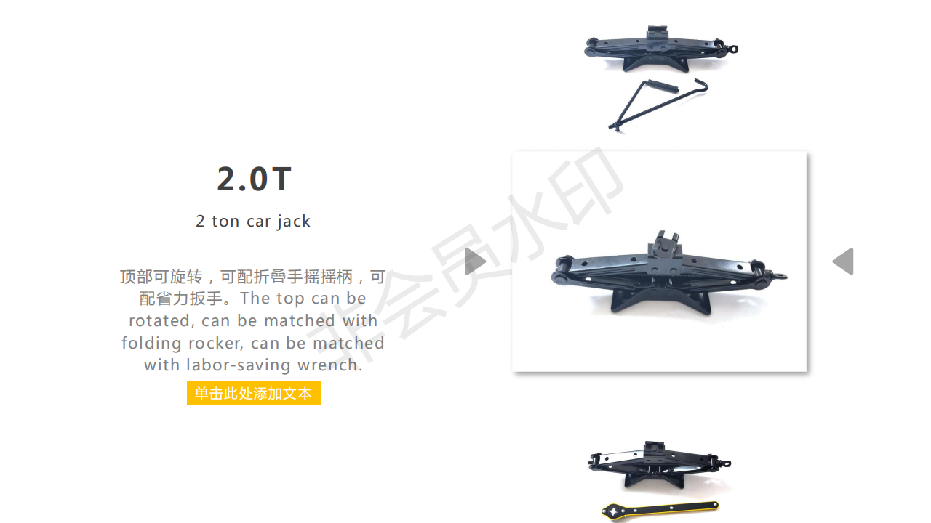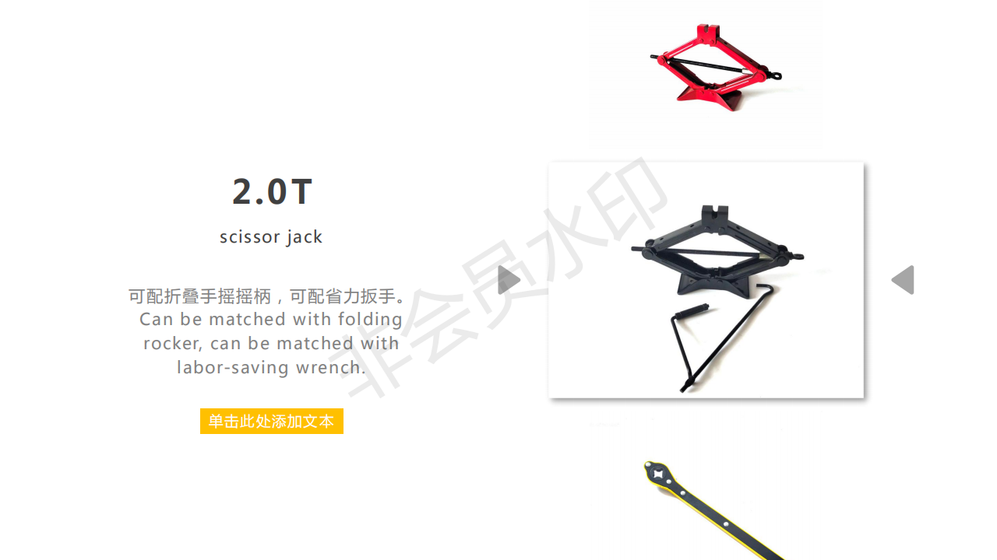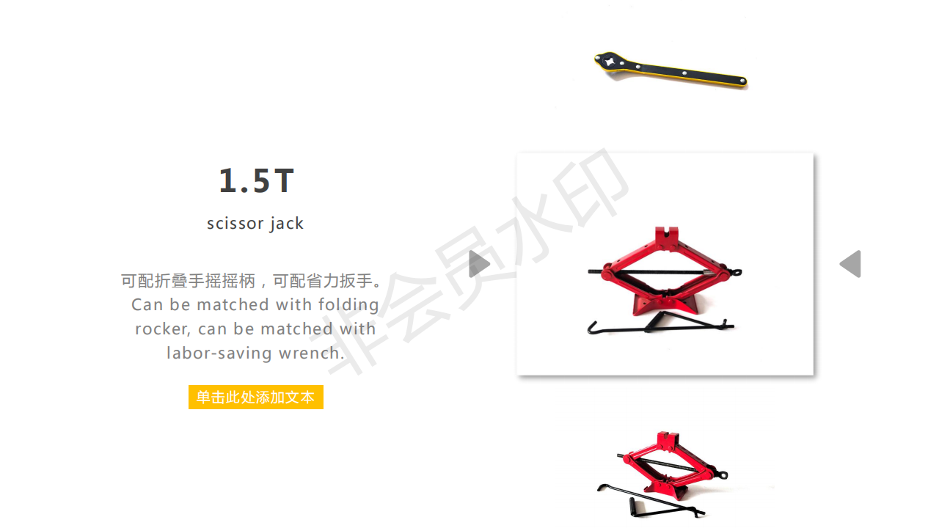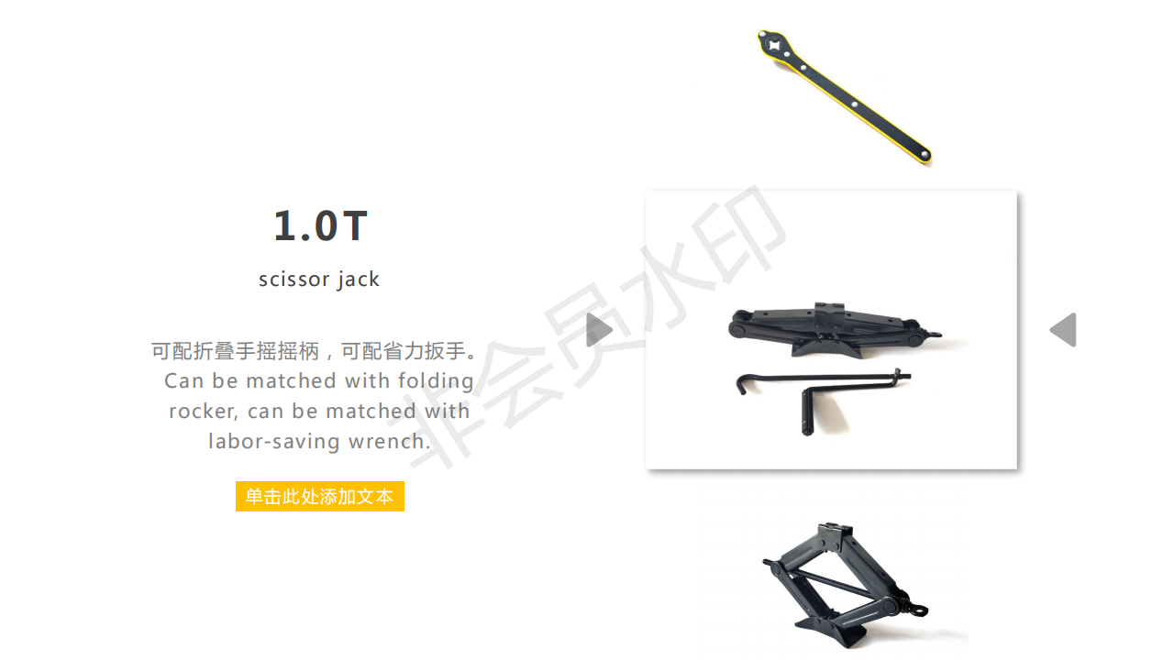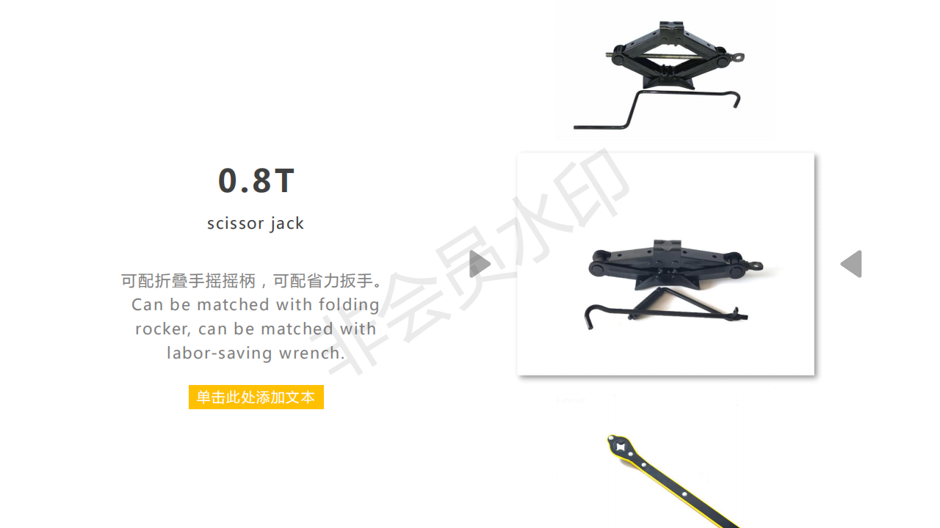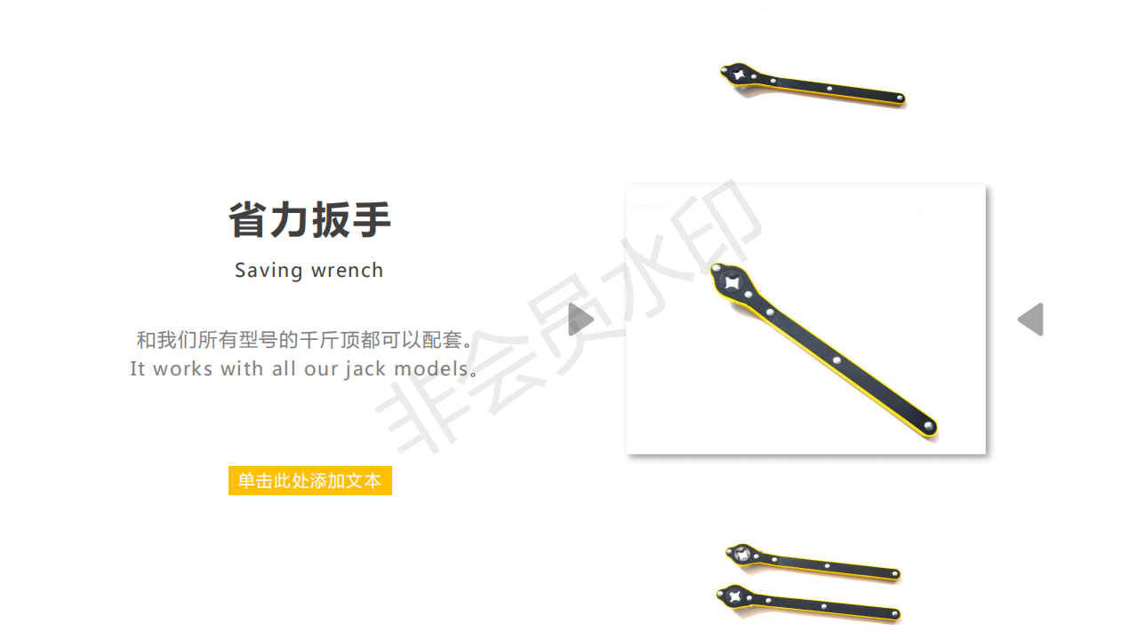
产品型号  product model | 0.8T | 1.0T | 1.5T | 2.0T | 2.0T-2
产品尺寸  Product size | 80*70*320（mm) | 370*70*80(mm) | 380*90*100（mm） | 105*105*470(mm) | 425*105*110
升起高度  Rising height | 80-280mm | 80-320mm | 90-340mm | 100-385mm | 110-400mm
产品承重  Products bearing | 800KG | 1000KG | 1500KG | 2000KG | 2000KG
适用车型  Applicable models | 电动三、四轮等0.8吨以下  Electric three, four and so on 0.8 tons or less | 轿车等吨以下  Cars under tons | 轿车、SUK越野车等  Sedans, SUK suvs, etc | 轿车、SUK越野车等  Sedans, SUK suvs, etc | 轿车、SUK越野车等  Sedans, SUK suvs, etc

