The featured car wash
Touch Free Car Wash Machine
Rollover Car Wash Machine
Tunnel Car Wash Machine
Self-service car wash
Bus and Truck Wash Machine
Automatic Wheel Wash Systems

Qingdao Risense Mechatronics Co., Ltd. As a prominent manufacturer, supplier and exporter, has grown to be a leading force to produce all kinds of car wash machine with the MK's advanced technology and core components from Japan.
Our specific goal was to develop a complete line of car wash machine that was rugged and durable, built with Japan parts and easy to install, operate and maintenance.
We have developed a strong reputation over the years amongst the client from Malaysia, Singapore, Middle East, Africa and Russia for providing a high quality car wash machine and amazing installation case with competitive price and after sales services.
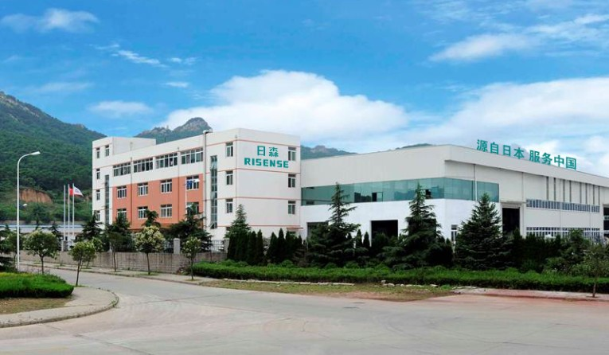

All of us at Risense take great pride in offering you best for your consideration. We are happy to answer any questions and concerns you may have or discuss with you which machine is best suit for your needs.
+86 15662756051
E-mail: altynai.risensecarwash@bk.ru

CH-200 Semi-Automatic Touch Free Car Wash Machine

Specification
Overall dimensions | 3950x3800x2690mm
Assembling range | 6300x4500mm
Moving range | 6200x4500mm
Available size for car | 5200x2300x2300mm
Available car to wash | car/jeep/coach within 10seats
Washing time | 1'30"(2 rollover)
Car wash capacity | 12-15cars/hour
Mains voltage | 3PHASE AC380V /50HZ
Total power | 7.5KW
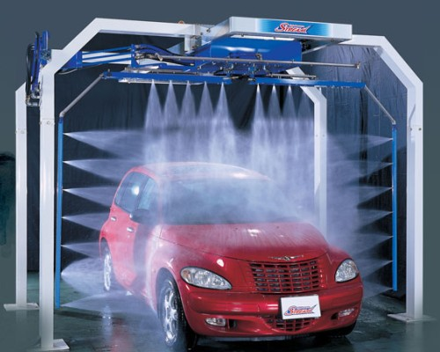

Main Features
  - No brush has a touch on car body directly keep the car body from harming.
  - Two arms can move freely which provides 360°spray on the vehicle surface while using less water than other spray systems.
  - CPU electronic control panels system can easy to operate and maintain.
  - Four wash ways combination with high pressure water, wax and foams at any will.
  - High cleaning efficacy with high pressure pumps can rinse car body cleanest.
  - The space for the machine is less and keeps more energy efficiency.
  - Humanized operation panel with CPU and voice prompt during wash progress.
  - High quality control systems, motors and pumps from Japan can keep the car wash running with great performance in any conditions.
  - The frequency changer on walking system can control the running speed precisely which make the foam and water sprayed properly.
  - With on-site installation and operate training for free and long time quality guarantee to whole car wash.
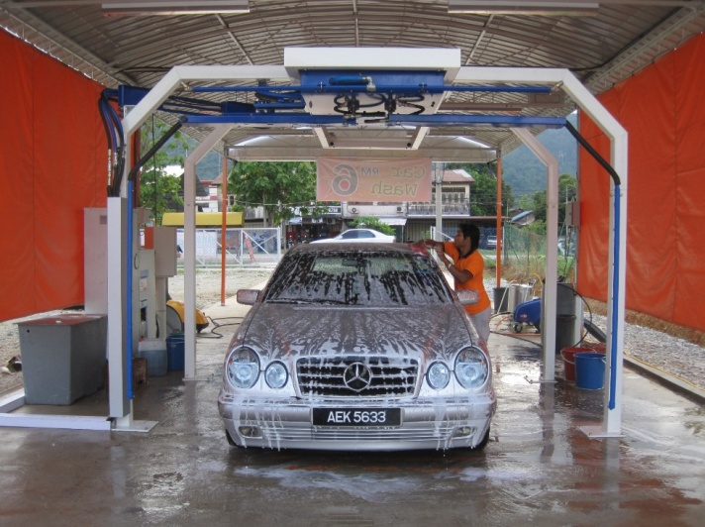
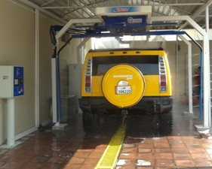
The installation case as below:

CF-350 Fully Automatic Rollover (mobile) Car Wash Machine

Specification
Overall dimensions | 2610x3600x2815mm
Assembling range | 10070x3700mm
Moving range | 10470x3700mm
Available size for car | 5200x2150x2270mm
Available car to wash | car/jeep/coach within 10seats
Washing time | 2'45"(1 rollover)/3'25"(2 rollover)
Car wash capacity | 12-15cars/hour
Mains voltage | 3 PHASE AC380V /50HZ
Total power | 10.45KW
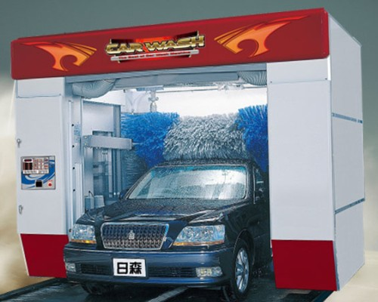

Main Features
  - Can identify the car body model with many pair photoelectric sensors.
  - Hot-dip galvanized frame can keep the whole machine stable and long life use.
  - CPU electronic control panels system can easy to operate and maintain.
  - Three function (Car wash, Inspection and management) to an operation panel.
  - Many wash procedure combination with high pressure water, wax and foams at will.
  - Inclinable side brush strengthens cleaning ability around the car body.
  - The dovetail foam brush makes the car washing more quiet and clean.
  - High efficiency shape drying to the car with photoelectric and approaching sensors.
  - The motor with IP67 make the machine work well in the water condition.
  - High quality control systems, motors and pumps from Japan can keep the car wash running with great performance in any conditions.
  - Fully automatic rolls over and easy to install, operate use and maintain.
  - With on-site installation and operate training for free and long time quality guarantee to whole car wash.
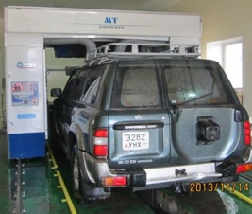
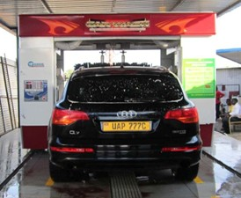
The installation case as below:

CF-330 Fully Automatic Rollover (mobile) Car Wash Machine

Specification
Overall dimensions | 2510x3600x3150mm
Assembling range | 11000x3700x3300mm
Moving range | 10000x3700mm
Available size for car | 5200x2100x2100mm
Available car to wash | car/jeep/coach within 10seats
Washing time | 2'45"(1 rollover)/3'25"(2 rollover)
Car wash capacity | 12-15cars/hour
Mains voltage | 3 PHASE AC380V /50HZ
Total power | 18.97KW
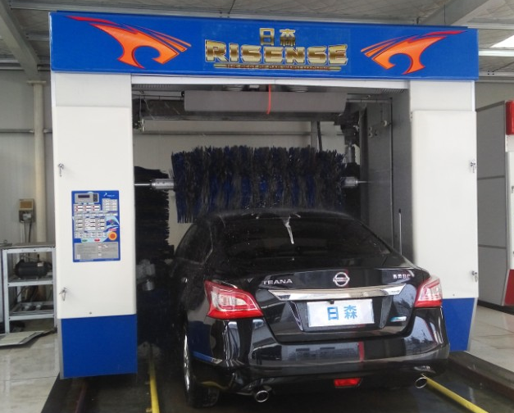

Main Features
  - Can identify the car model with photoelectric sensor.
  - With PLC electronic control panels system.
  - Hot-dip galvanized frame keep the whole machine stable and long life use.
  - Inclinable side brush strengthens cleaning ability around the car.
  - The dovetail foam brush makes the car washing more quiet and clean.
  - Three functions (Car wash, Inspection and management) to an operation panel.
  - High efficiency shape drying to the car with photoelectric and approaching sensors.
  - Electric motor waterproof IP67 make the machine work well in the water.
  - High quality control systems, motors and pumps from Japan can keep the car wash running with great performance in any conditions.
  - Fully automatic rolls mobile and easy to install, operate and maintenance.

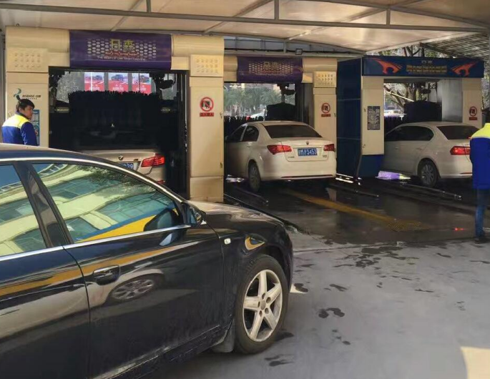
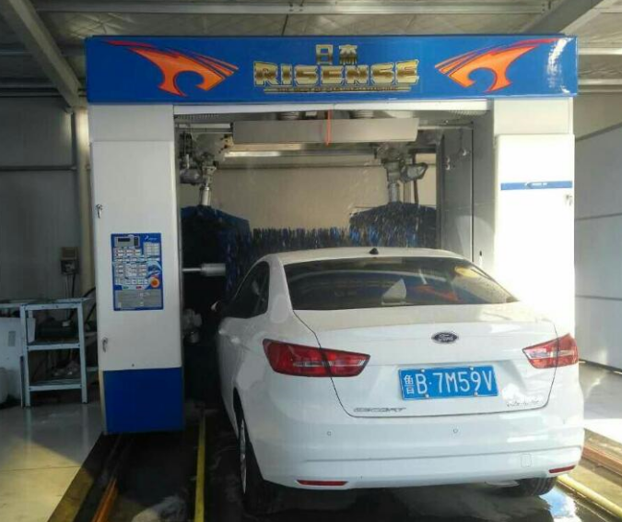
The installation case as below:

CC-690 Fully Automatic Tunnel Car Wash Machine

Specification
Overall dimensions | 9500x3800x3440mm
Assembling range | 11600x3800mm
Moving range | 11600x3800mm
Available size for car | 5200x2150x2200mm
Available car to wash | car/jeep/coach within 10seats
Washing time | 1'12"/car
Car wash capacity | 45-55cars/hour
Mains voltage | 3PHASE AC380V /50HZ
Total power | 34.82KW
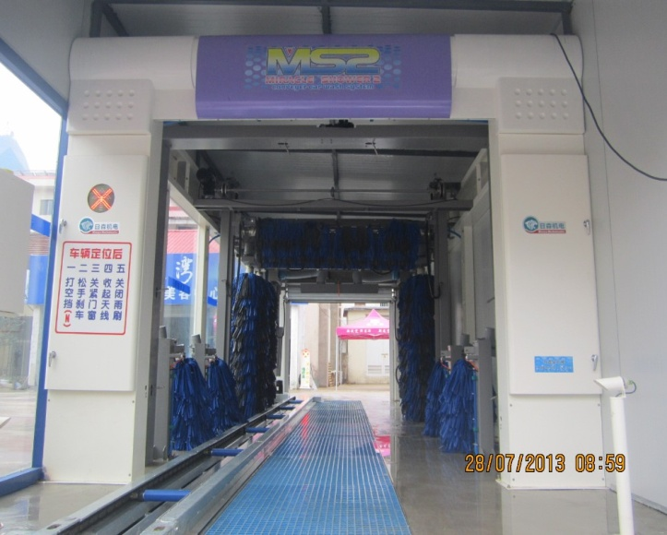

Main Features
  - Can identify the car model with photoelectric and approaching sensors.
  - Hot-dip galvanized frame can keep the whole machine stable and long life use.
  - PLC electronic control panels system can easy to operate and maintain.
  - Three function (Car wash, Inspection and management) to an operation panel.
  - Many wash procedure combination with high pressure water, wax and foams at will.
  - Inclinable side brush strengthens cleaning ability around the car body.
  - The dovetail foam brush makes the car washing more quiet and clean.
  - High efficiency shape drying to the car with photoelectric and approaching sensors.
  - The motor with IP67 make the machine work well in the water condition.
  - High quality control systems, motors and pumps from Japan can keep the car wash running with great performance in any conditions.
  - The electroplated conveyor was equipped with the tire corrector device system.
  - The LED warning light in the entrance can be recognized by driver easily.
  - Fully automatic wash in the bay and easy to install, operate use and maintain.
  - With on-site installation and operate training for free and long time quality guarantee to whole car wash.
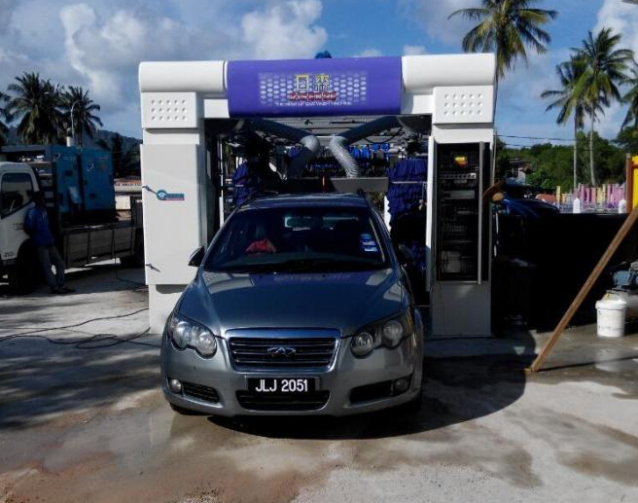
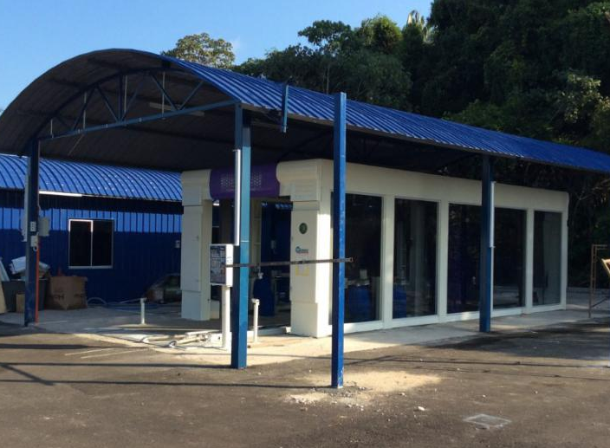
The installation case as below:

CC-695 Fully Automatic Tunnel Car Wash Machine

Specification
Overall dimensions | 17800x3800x3440mm
Assembling range | 22000x3800mm
Moving range | 22000x3800mm
Available size for car | 5200x2150x2200mm
Available car to wash | car/jeep/coach within 10seats
Washing time | 1'12"/car
Car wash capacity | 45-55cars/hour
Mains voltage | 3PHASE AC380V /50HZ
Total power | 39.82KW
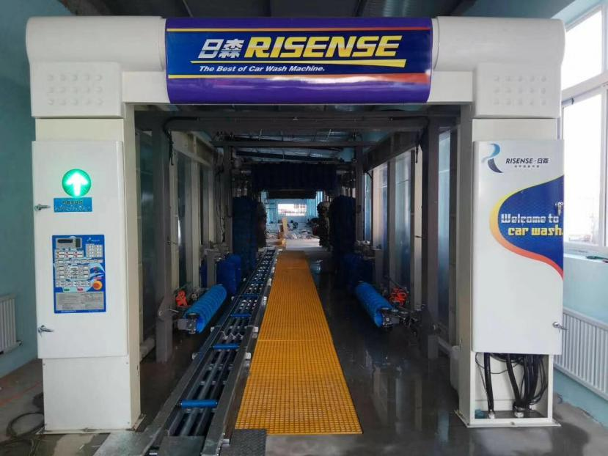

Main Features
  - High pressure water pre-washing and chassis sprinkling
  - Shampoo(Foams) sprinkling and wax washing systems.
  - Nine brushes with foam material and lifelong warranty.
  - Three blowers dry the car body completely and precisely.
  - Three polishing brushes with chamois leather.
  - Two wheel wash brushes to wash the tires.
  - PLC control system & humanized operate panel.
  - Intelligent avoidance system to wash all kinds of car types.
  - Main technology and machine design from Japan.
  - Electroplated conveyor equipped with the tire corrector device.
  - Hop-dip galvanized steel frame keep the whole machine antirust.
  - Motors, electrical apparatus, pumps all imported from abroad.
  - With one year’s warranty and lifelong maintenance service.
The installation case as below:
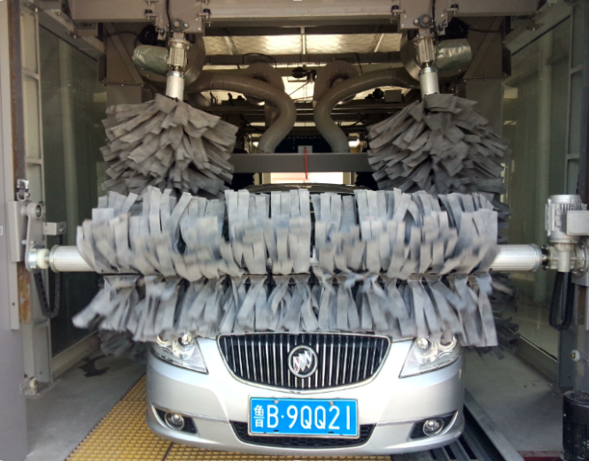
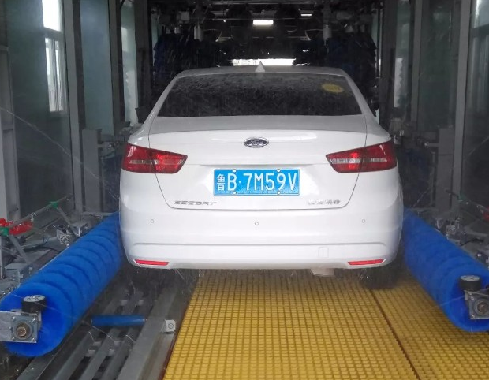

CB-730 Automatic Bus and Truck Wash Machine

Specification
Overall dimensions | 2150x4680x5200mm
Assembling range | 25000x6580mm
Moving range | 25000x5114mm
Available size for car | 18000x2700x4200mm
Available car to wash | Bus/ truck/coach/ container truck.
Washing time | 2'50"/each one
Car wash capacity | 20 buses/hour
Mains voltage | 3PHASE AC380V /50HZ
Total power | 34.82KW
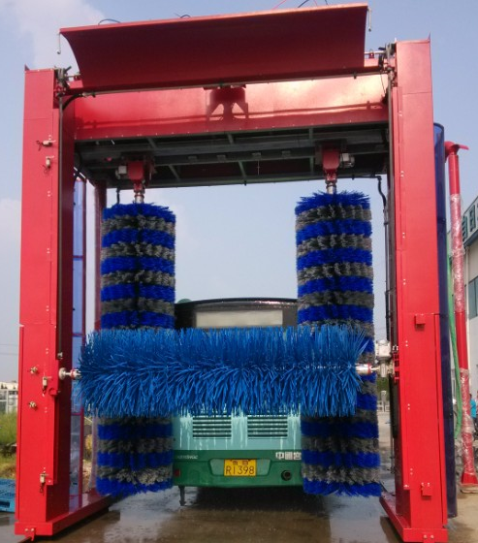

Main Features
  - Can identify the car model with photoelectric and approaching sensors.
  - Hot-dip galvanized frame can keep the whole machine stable and long life use.
  - PLC electronic control panels system can easy to operate and maintenance.
  - The nylon material brush makes the car washing more quiet and clean.
  - High quality control systems, pumps and motors from Italy.
  - The high sensor on the top brush can keep the bus from damage.
  - The motor with IP67 make the machine work well in the water condition.
  - Fully automatic to wash the bus and truck body thoroughly.
  - With on-site installation and operate training for free and long time quality guarantee to whole wash machine.
The installation case as below:
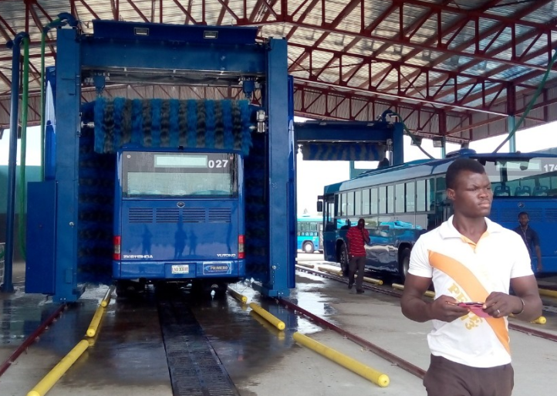
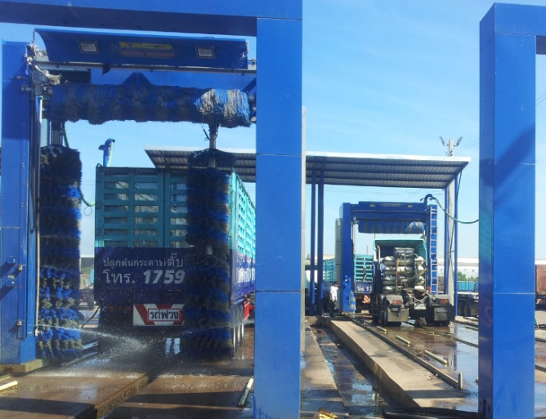

PQ-107 Self Service Car Wash Machine

Specification
Overall dimensions | 780x400x1480mm
Height of arms | 3500mm
Length of pipes | 6000mm
Available car wash | all small cars
Water pressure | 60-80bars
Air pressure | 0.75-0.9Mpa
Functions | High pressure water/ Shampoo/ Wax
Mains voltage | 3PHASE AC380V /50HZ
Total power | 2.2KW
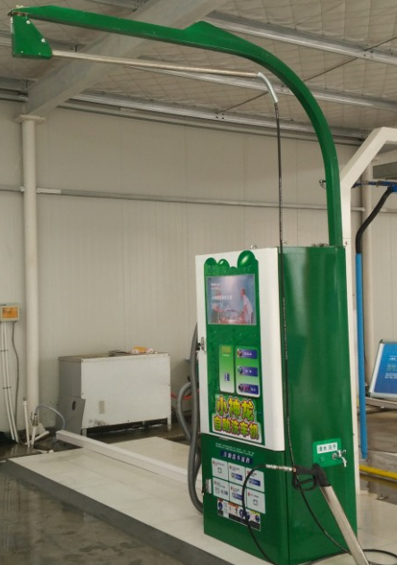

PQ-109 Self Service Car Wash Machine

Specification
Overall dimensions | 800x580x1750mm
Height of arms | 2850mm
Length of pipes | 5000mm
Vacuum pipes | 5000mm
Available car wash | all small cars
Water pressure | 60-80bars
Functions | High pressure water/ Foams/ Vacuum cleaner
Mains voltage | AC220V /50HZ
Total power | 5.5KW
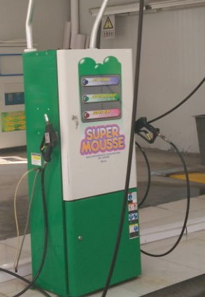

CV-800Car Vacuum Cleaner

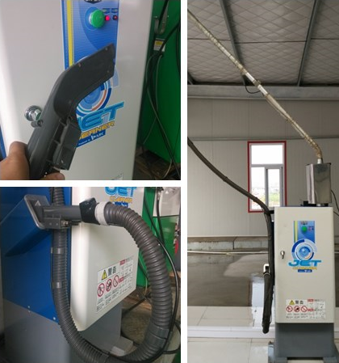
Specification
Overall dimensions | 652x522x3600mm
Swing arm height | 3500mm
Length of power line | 5000mm
Cleaning ways | Wind absorbing and blowing
Mains voltage | 3PHASE AC380V /50HZ
Total power | 4.5KW
Chamber capacity | 28L
Max.blowing rate | 9.7m³/min
Air pressure | 0.75-0.9Mpa
Max.air pressure | 22.5Kpa

CM-900Car Mat Cleaning Machine

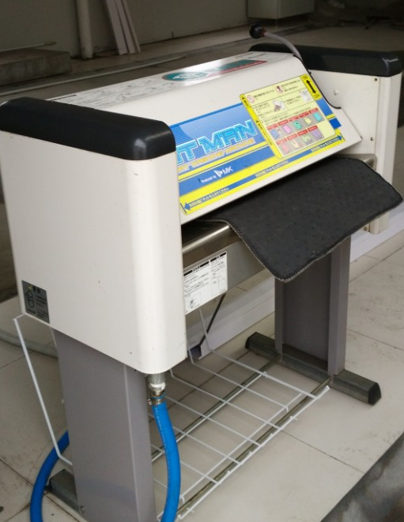
Specification
Overall dimensions | 933x648x1120mm
Mains voltage | 3PHASE AC380V /50HZ
Total power | 3.3 KW
Gross Weight | 68KGS
Water consumption | 13L/min
Min.water pressure | 0.04MPa（0.4kgf/cm2）
Available car mat | All kinds of car mats
Available size mat | Width:600mm, Thickness:30mm
Washing ways | Single surface
Washing speeds | 8-9s for 60cm length mat

