Contact Person: Manufactory Supplier.: Zhejiang Hulong Industry & Trade Co.,Ltd
Jessie Chen Add: NO.468 North Jiulong Road,Yongkang City, Zhejiang Province,China
Quotation Tel : 0086-579-86469339 Fax : 0086-579-86469011
Date:2017.5.11 Whatsapp : +86 15958467586
Web : www.hulonggroup.com
Validity: 30 days
Kick Scooter Price List ( MOQ :1000PCS )
Price Terms: FOB Ningbo
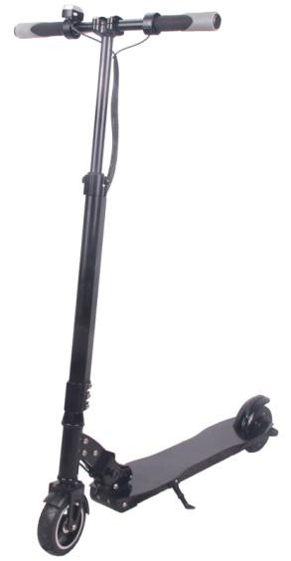 | Product Name | Electric Scooter
 | ITEM No. | HL-C1
 | FOB price | usd 140
 | Material | Aluminum
 | Motor | 150w DC motor
 | Display | LED Display
 | Battery | lithium battery 24V/4.4Ah(Chinese battery)
 | Charger | Input AC100-240V
 | Charging time | 3-4hours
 | Suspension | Front
 | Front light | optional
 | Max speed | ≤25km/h
 | Max load | 100KG
 | Climbing capability | ≤8degrees slope
 | Range | 14-16km
 | Tire | 5.5"X2.0,solid tire
 | Brake | Electronic brake with step brake
 | Color | optional
 | G.W/N.W | 12.5KGS/9KGS
 | Certification | EMC & SGS, EN14619 & TUV-SUD, ASTM F2641
 | Battery optional | 24V/4.4Ah-36V/10AH SAMSUNG AND LG BATTERY  OPTIONAL
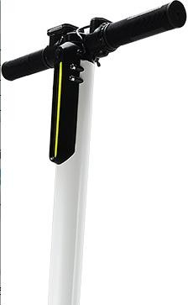 | Product Name | Electric Scooter
 | ITEM No. | HL-F1
 | FOB price | usd 173/ USD137
 | Material | Carbon fiber/Aluminum
 | Motor | 250w DC motor
 | Display | LED Display
 | Battery | lithium battery 24V/4.4Ah(Chinese battery)
 | Charger | Input AC100-240V
 | Charging time | 3-4hours

 | Suspension | Front
 | Front light | optional
 | Max speed | ≤23km/h
 | Max load | 100KG
 | Climbing capability | ≤8degrees slope
 | Range | 12-15km
 | Tire | 5.5"X2.0,solid tire
 | Brake | Electronic brake with step brake
 | Color | optional
 | G.W/N.W | 9.25KGS/7KGS 9.95kg/7.75kg
 | Battery optional | 24V/4.4Ah-36V/10AH SAMSUNG AND LG BATTERY  OPTIONAL
Note
- Range and blimbing capability testing data is basing on 75kg load,flat road and 25 degree Celsius environment temperature.
- The price is based on FOB Ningbo port and keeps valid for 30days. 3.Delivery time is 45-60days upon confirmation of order and deposit.
4.Payment terms shall be 30% deposit and the balance with the copy of B/L by T/T.
