Watches Catalogue
Yiwu Deyi Trading Co.,Ltd Web :deyi888.en.alibaba.com
Contact information :Deree Lee +86 18757510188
Product type | Model | Picture | Color | Price
Quartz watch | S004 | 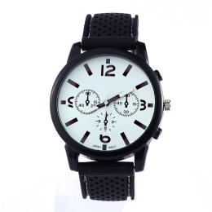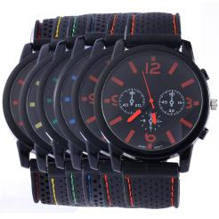 | Red  Yellow  Green  Blue  Orange | USD1.1-1.28
Quartz watch | S003 | 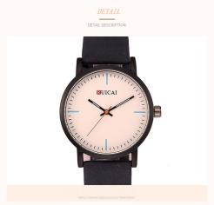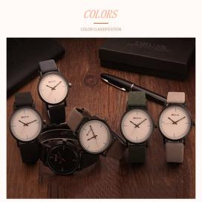 | As the picture | USD1.98-2.61
Quartz watch | S012 | 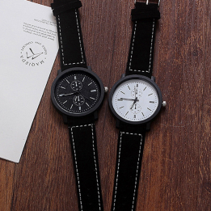 | Black  White | USD1.16-1.54
Quartz watch | S015 | 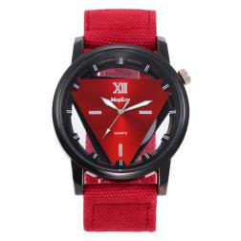 | Red  Green  Black  Blue  Orange | USD1.98-2.35
Quartz watch | S016 | 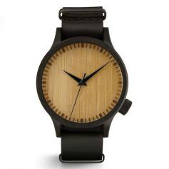 | Brown  Black | USD2.27-2.65
Quartz watch | S025 | 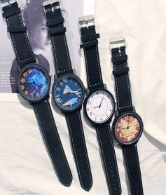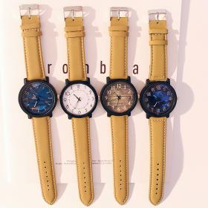 | As  Picture | USD1.02-1.35
Quartz watch | M005 | 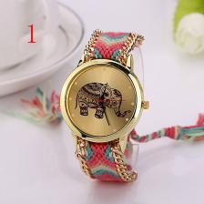 | 11 colors | USD1.05-1.3
Quartz watch | M006 | 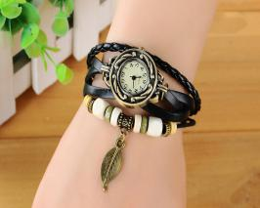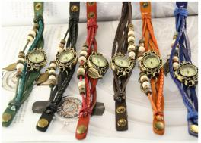 | As  picture | USD1.05-1.3
Quartz watch | M007 | 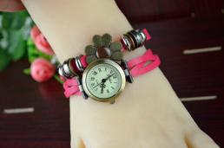 | Red  Yellow  Pink  Orange | USD1.1-1.39
Quartz watch | M009 | 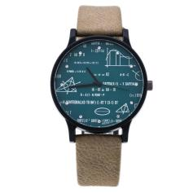 | Black  Brown  Red | USD1.68-2.13
Quartz watch | M010 | 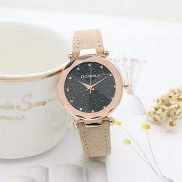 | White  Blue  Red  Green | USD1.83-2.23
Quartz watch | M011 | 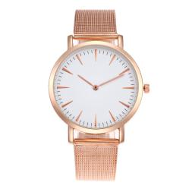 | Gold  Silver  White | USD1.55-1.92
Quartz watch | M013 | 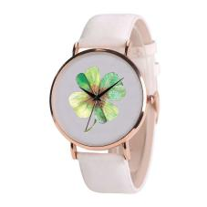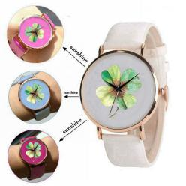 | As  picture | USD1.61-1.98
Quartz watch | S014 | 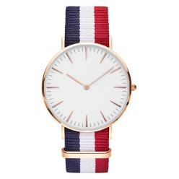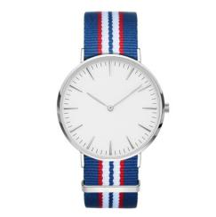 | Gold  Silver | USD0.92-1.35
Quartz watch | M017 | 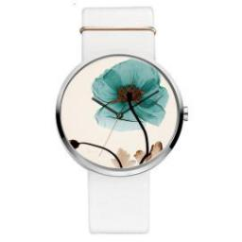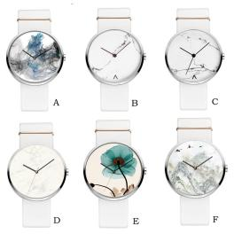 | As  Picture | USD2.27-2.65
Quartz watch | M018 | 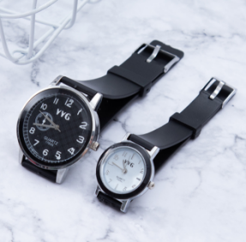 | Black | USD1.04-1.5
Quartz watch | M019 | 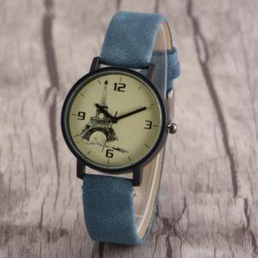 | Black  Red  Blue  Green  Yellow | USD1.44-1.83
Quartz watch | M020 | 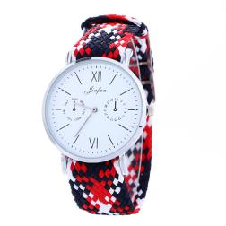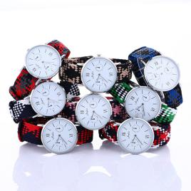 | As  Picture | USD1.64-2.08
Quartz watch | M021 | 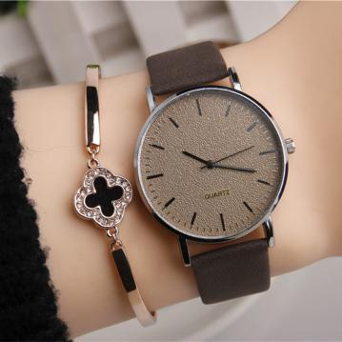 | Brown  Black | USD1.65-2.05
Quartz watch | M022 | 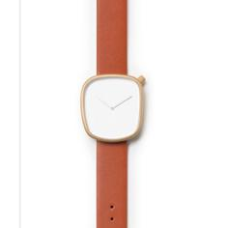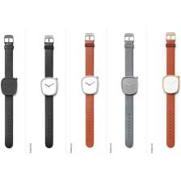 | As  Picture | USD3.23-3.75
Quartz watch | M023 | 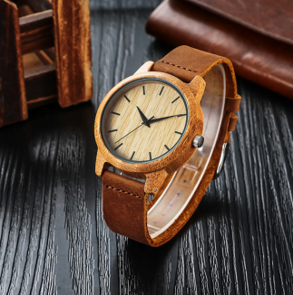 | Brown | USD6.32-6.59
Quartz watch | M024 | 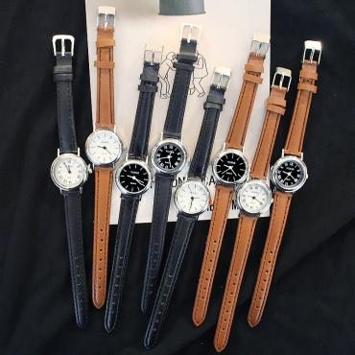 | As  Picture | USD1.15-1.39
Quartz watch | M026 | 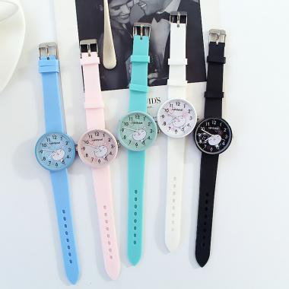 | As  Picture | USD0.95-1.25
Quartz watch | M027 | 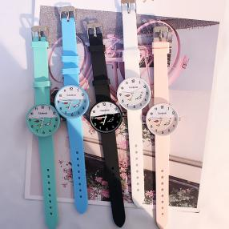 | As  Picture | USD0.95-1.25
Quartz watch | M028 | 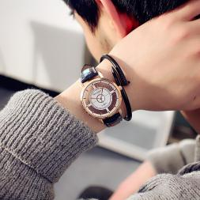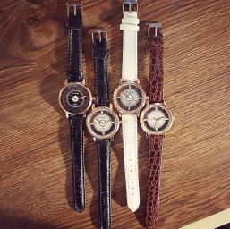 | As  Picture | USD1.25-1.55
Quartz watch | M029 | 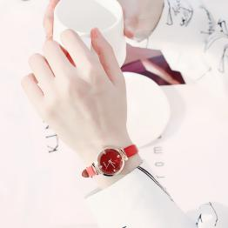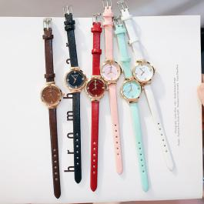 | As  Picture | USD1.17-1.54
Quartz watch | M030 | 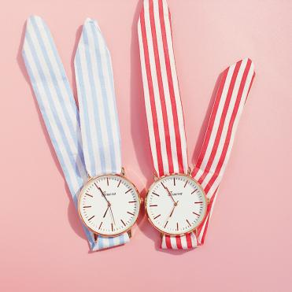 | Red  Blue | USD0.95-1.32
Quartz watch | M031 | 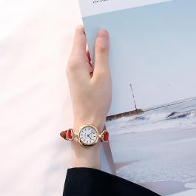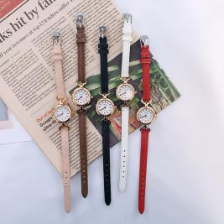 | As  Picture | USD1.18-1.78
Quartz watch | M032 | 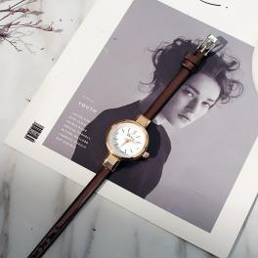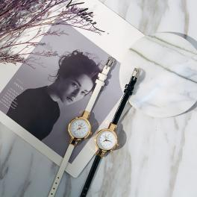 | As  Picture | USD1.02-1.35
Quartz watch | S033 | 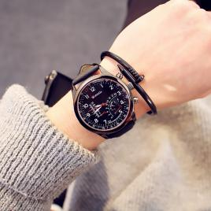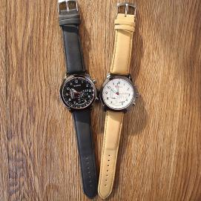 | As  Picture | USD1.95-2.2
Quartz watch | M034 | 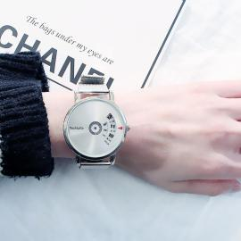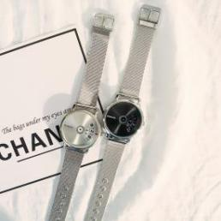 | As  Picture | USD1.85-2.35
Quartz watch | M035 | 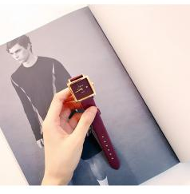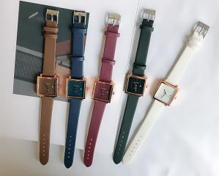 | As  Picture | USD1.76-2.2
Electronic  watch | S036 | 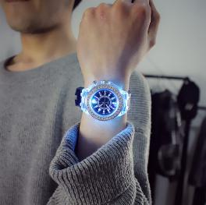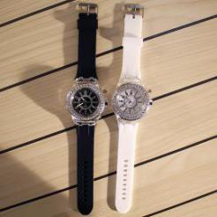 | White  Black | USD1.55-2.05
Quartz watch | S037 | 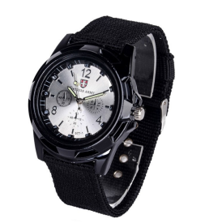 | Black  Green  Blown | USD1.08 - 1.48
Electronic  watch | S038 | 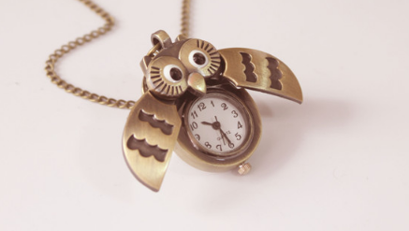 | Bronze | USD1.31 - 1.67
Quartz watch | S039 | 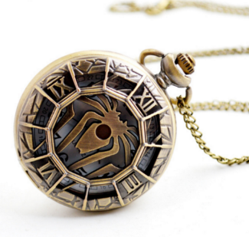 | Bronze | USD1.37-1.82
Quartz watch | S040 | 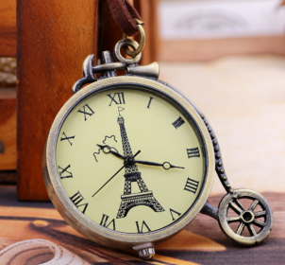 | Bronze | USD2.03-2.41
Quartz watch | S041 | 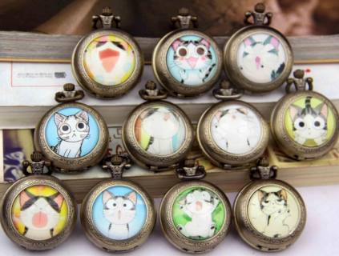 | Bronze | USD1.92-2.35
Quartz watch | S042 | 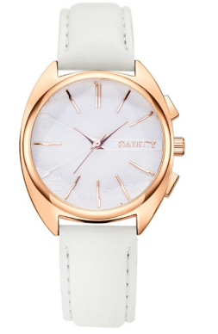 | White  Red  Pink  Bluck  Brown | USD1.6 - 1.89
Quartz watch | S043 | 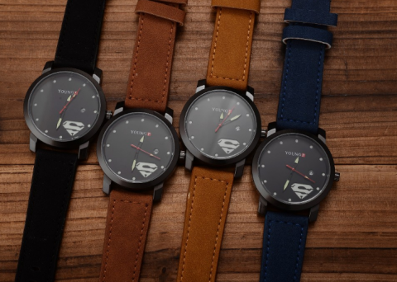 | Blue  Black  Brown  Coffee | USD2.78-3.08
Quartz watch | S044 | 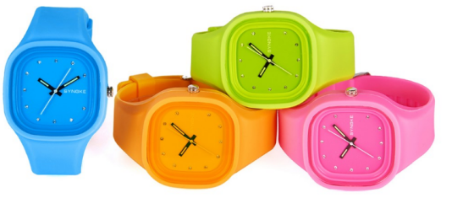 | Green  White  Black  Blue  Pink | USD2.28-2.65
Quartz watch | S052 | 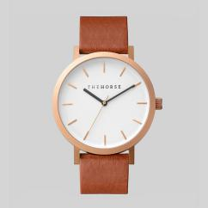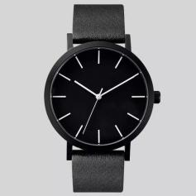 | As picture | USD1.72-1.98
Quartz watch | W050 | 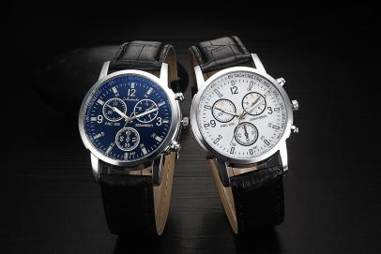 | As picture | USD0.75-1.15
Quartz watch | W051 | 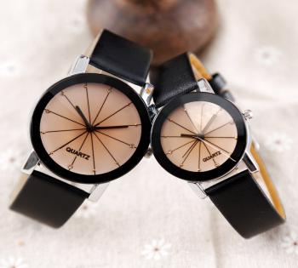 | Black and white | USD0.81-1.11
Electric watch | E052 | 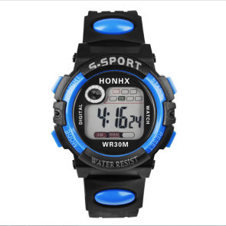 | Black, red, yellow,orange,blue, | USD1.08-1.38
Electric watch | E053 | 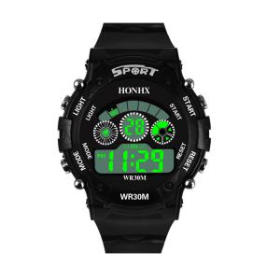 | Black, red, yellow,orange,blue, | USD1.12-1.35
Electric watch | E054 | 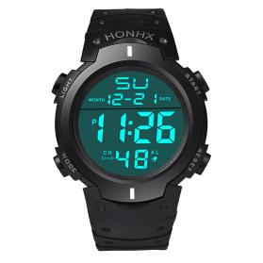 | Black | USD2.25-2.85
Electric watch | E055 | 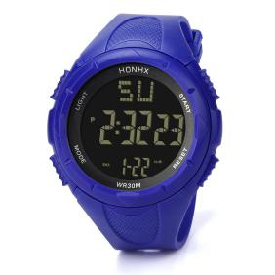 | Black, pink, blue, gray, sky blue, | USD2.25-2.85
Electric watch | E056 | 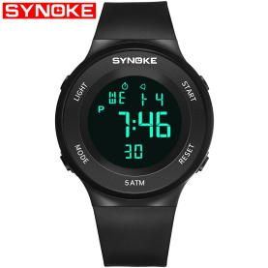 | Black, white | USD3.75-4.45
Electric watch | E057 | 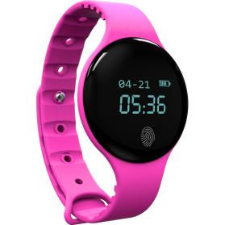 | Black, pink, blue, red | USD6.06-6.66
Quartz watch | W058 | 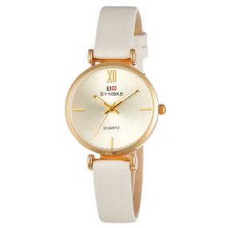 | Black, pink, red, green, white | USD1.78-2.28
Quartz watch | W059 | 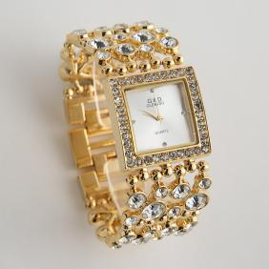 | Gold, silver | USD5.78-7.28
Quartz watch | W060 | 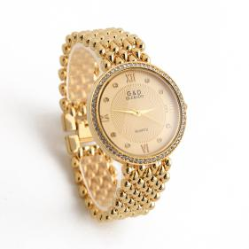 | Gold, silver | USD5.92-6.82
Quartz watch | W061 | 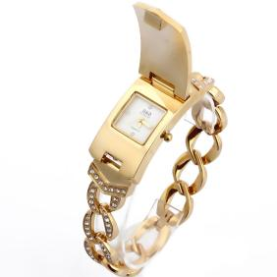 | Gold, silver | USD5.18-6.08
Quartz watch | W062 | 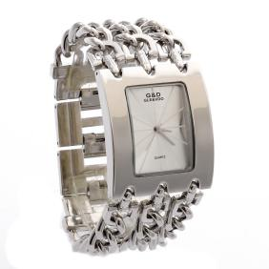 | Gold, silver | USD4.82-5.62
Quartz watch | W063 | 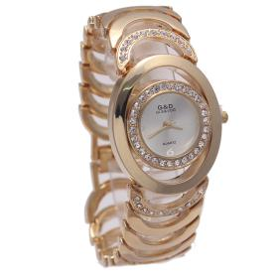 | Gold, silver | USD6.22-7.12
Quartz watch | S064 | 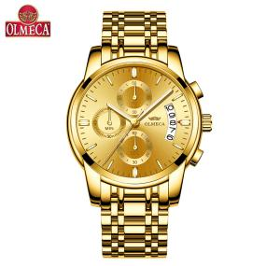 | Gold, black, white, blue | USD9.18-10.18
Quartz watch | S065 | 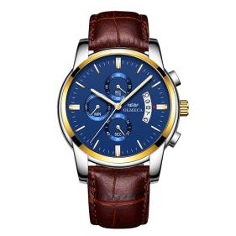 | Blue, black, gray, white, brown | USD7.38-8.18

